DESIGN AND IMPLEMENTATION OF A WEB APPLICATION FOR AN E-LEARNING PLATFORM

BY

#### SANNI OPEYEMI MOSHOOD

MATRIC NUMBER: 180591052

SUBMITTED TO

THE DEPARTMENT OF COMPUTER SCIENCE

FACULTY OF SCIENCE

LAGOS STATE UNIVERSITY (LASU)

IN PARTIAL FULFILMENT OF THE REQUIREMENT FOR THE AWARD OF BACHELOR’S DEGREE (B.SC) IN COMPUTER SCIENCE

SUPERVISED BY

PROF. RAHMAN, M.A

ASSISTANT SUPERVISOR

MR. SHANU, R.O

# 

# **CERTIFICATION**

This is to certify that this research work was carried out by SANNI OPEYEMI MOSHOOD, matriculation number 180591052, Department of Computer Science, under close guidance and supervision.

|  |  |  |
| --- | --- | --- |
| NAME OF STUDENT |  | SIGNATURE AND DATE |

|  |  |  |
| --- | --- | --- |
| NAME OF SUPERVISOR |  | SIGNATURE AND DATE |

**CHAPTER ONE**

# **INTRODUCTION**

## 1.0 BACKGROUND OF THE STUDY

Learning is the process by which a person acquires knowledge and skills through learning and experience. Learning is essential for all humans. Learning helps us grow and develop. Humans have learned since time began. E-learning (electronic learning) is a form of learning that typically uses electronic media, usually the Internet. Sometimes called online learning or virtual learning, virtual learning involves more interaction between learners and tutors. E-learning is a system that provides knowledge or information to learners or users regardless of physical distance or time constraints. It can also enable interaction between trainers and learners, or between learners themselves.

As of April 2022, there will be over 5 billion internet users worldwide, representing 63.1% of the world's population. On November 15, 2022, the world's population is projected to reach 8 billion people, a milestone in human development. (*United Nations, 2022)*

With so many people surfing the internet today, it's no surprise that we ought to learn on it too. According to (Rungta, K. 2022), at least 60% of internet users are engaged in online learning. This is because they can be convenient in time and place. 80% of companies and 50% of college students are using e-learning platforms. E-learning takes 40% to 60% less time for employees and students than conventional learning.

The term "e-learning" first appeared in 1999, when it was first used in a seminar on CBT systems. A search for the exact description also yielded other terms such as "online learning" and "virtual learning." However, the principles behind e-learning are well documented throughout history, and there is even evidence that early forms of e-learning existed in the 19th century.   
The first test machine he invented in 1924. Learners can test themselves with this device.

Then, in 1954, Harvard University professor BF Skinner invented his "teaching machine," allowing schools to teach their programmed lessons to students. However, it was not until 1960 that the world's first computerised training program was introduced. This CBT (Computer Based Training) program was known as PLATO (Programmed Logic for Automated Teaching Operations). Initially designed for students at the University of Illinois, it was eventually used by schools throughout the area. The first e-learning system was set up just to deliver information to students, but in the 1970s, e-learning started to become more interactive. In the UK, the Open University wanted to use eLearning. Their education system has always been primarily geared toward distance learning.

In the past, course materials were delivered by mail, and correspondence with tutors was also mailed. With the Internet, the Open University began offering a wider range of interactive educational experiences as well as faster communication with students, such as via email (LLC Epignosis, 2014).

During the start of the Coronavirus Disease 2019 (COVID-19) pandemic, over 1.2 billion children around the world were forced to stay home for months while school activities were suspended. Some schools are able to adapt to these conditions and continue their learning activities through the use of e-learning environments. By using 3D virtual environments, some schools have been able to recreate real-life classroom scenarios using virtual reality. For students whose schools were unable to borrow these styles, they can always visit the e-learning website to learn more about different fields.

## 1.1 STATEMENT OF THE PROBLEM

Students usually experience setbacks because of the teaching methods adopted in some schools. These setbacks can be mental, environmental, or due to other factors unrelated to available resources.

Following research by (E. Hendrix, 2019), they found that the learning environment plays an important role in student success. Several factors can affect your ability to learn, including seating, lighting, noise, and even colour. Students who learn in positive learning environments have been shown to be more motivated, engaged, and generally more capable of learning. On the other hand, students studying in poor environments (uncomfortable, noisy, and full of distractions) have a much harder time absorbing information and staying focused. It is a challenge when students cannot learn due to environmental factors, as schools cannot simply change location, and it would be a challenge to find a perfect location that will be suitable for every student.

According to Statista (2019), 40% of students said e-learning was more efficient than in-person training, and that modules were simplified for better understanding. Some schools have difficulty providing an adequate teaching structure for large numbers of students, and some lecturers may be inaudible to their students.  
  
 After the World Health Organization (WHO) officially declared COVID-19 a pandemic, most schools sent their students home. About 70% of the global student population was affected by this closure. Countries first hit by the virus, including China, Italy, and South Korea, have introduced online homeschooling using online learning tools and platforms. The US, China, India, the UK, and South Korea invest the most in e-learning. The largest number of students taking online courses are in higher education, especially in post-graduate programs (guru99.com).

## 1.2 AIM AND OBJECTIVES

## 

The aim of this research is to develop a web-based e-learning platform that provides students with a comprehensive and interactive learning experience in computer science courses.

## The objectives of the study are:

## Do a literature review on existing literatures, books, articles, websites, and projects on e-learning.

* Design and Implementation of a model for an e-learning platform where learning takes place.

## Testing and evaluation of the e-learning application for its functionality.

* To provide an alternative means of acquiring education in addition to traditional learning methods.

## 1.3 SIGNIFICANCE OF THE STUDY

The relevance of this research is to create an environment where people can learn and acquire knowledge at their own time. From this study, we can learn the benefits of e-learning and understand why, despite its tremendous growth and global success in recent years, it has not been fully embraced and adopted by students and institutions.

It also facilitates the effective learning of subjects from different academic disciplines. Learners can access the platform whenever they are ready to learn at their own pace, but in traditional school systems, everything that is taught is packed into a few lesson sessions, with realistically not enough time for the learner to really assimilate each lecture and progress at the lecturer’s pace. The cost of e-learning is higher than the cost of traditional learning. The financial, physical (stress-related), and even emotional costs are not as high as traditional learning. Students may not even have to leave where they live to study. It provides a learning environment for computer science students. This survey is primarily aimed at computer science students. The proposed platform will provide computer science students with easy access to learning materials.

## 1.4 APPROACHES TO E-LEARNING

There are two main approaches to e-learning. Synchronous and asynchronous learning. In asynchronous learning, learners and tutors have freedom of time and location to participate in the interaction, examples include interaction using e-mail, discussion forums, and bulletin board systems. Synchronous learning requires that all participants of interaction are online at the same time. Examples include voice telephone, video teleconferencing, instant messaging systems, text-based virtual learning environments, graphical virtual reality environments, and lecture room systems. Asynchronous online learning is an unsynchronized learning method, provided that the presence of teachers and students can be distinct.

The synchronous method is the opposite, where the presence of teachers and students must exist at the same time, and they must meet online and work together on the platforms they decide to work on, just as they do in the classroom. The hybrid method is a combination of both synchronous and asynchronous ways of learning. (Amiti, F. 2020).

### 1.4.1 Differences between Synchronous and Asynchronous learning

According to ChatGPT (January 2023), some differences between synchronous and asynchronous learning are:

In synchronous learning, students and instructors participate in online classes in real-time. This means that the students and instructors are online at the same time, and they interact with each other in real-time through video conferencing or other real-time communication tools. In asynchronous learning, on the other hand, students and instructors do not need to be online at the same time. Instead, students can access the course materials and complete their assignments on their own schedule. The instructors and other students may be available for support and discussion, but the interaction is not happening in real-time.

Synchronous learning is often more engaging and interactive, as it allows for real-time interaction between students and instructors. It can also be more structured, with set class times and schedules. Asynchronous learning, on the other hand, is more flexible and convenient. Students can access the course materials and complete their assignments on their own schedule, which can be beneficial for students with busy lives or other commitments. Asynchronous learning can also be more self-paced, allowing students to move at their own speed.

Synchronous learning may be better suited for students who prefer a more traditional classroom setting and enjoy real-time interactions with instructors and classmates. Asynchronous learning may be better suited for students who prefer a more independent learning style and do not need the same level of direct interaction with instructors and classmates.

## Overall, the choice between synchronous and asynchronous learning depends on the individual student and the specific course. Some students may prefer the structure and interactivity of synchronous learning, while others may prefer the flexibility and convenience of asynchronous learning.

## 

## 1.5 SCOPE OF THE STUDY

This study is focused on developing a web-based E-learning platform for students of Lagos State University (LASU) in the field of computer science.

## 1.6 LIMITATION OF THE STUDY? OR E-LEARNING?

There are several limitations to e-learning that impact the development and implementation of such systems. These limitations include:

1. The e-learning platform must be adaptable to changing circumstances, such as changes in the curriculum. This requires a flexible and scalable platform that can evolve over time.
2. Limited availability of certain courses: Not all course materials were available and obtainable and some courses are all about practicals which can be difficult to implement in an e-learning system.
3. Creating and managing content can be a challenging task. Lecturers may need to create different types of content such as videos, images, audio recordings, and interactive quizzes. This requires additional resources and time.
4. Accessibility: The e-learning platform does not include accessibility features for all students, including those with disabilities.
5. It can be challenging to replicate the same level of interaction that occurs in a physical classroom.
6. It requires a robust infrastructure to handle the traffic from multiple users. This may require significant investment in servers, bandwidth, and other resources.

## 1.7 DEFINITION OF TERMS

**Web/Website**: A collection of web pages with related contents that share or can be accessed by a single domain name.

**System**: It is a collection of interrelated components that work together to achieve a common goal or meet specific objectives.

**Database**: It is a collection of interrelated and interdependent groups of data/information.

**Internet/Net**: A global system of interconnected computer networks.

**Virtual reality (VR)**: A technology that allows users to experience a simulated environment through a computer.

**Web portal** is a specially designed website that brings information from diverse sources like emails, online forums, and search engines together in a uniform way.

**Synchronous learning**: It is a type of educational instruction that occurs in real-time, with students and teachers participating at the same time.

**Asynchronous learning**: It is a type of educational system in which students and instructors do not have to be present at the same time in order to participate in the learning process.

**Virtual learning environment** (**VLE**)**:** A virtual learning environment is a type of educational technology that allows students and teachers to access educational resources, communicate with each other, and complete assignments and assessments online.

**E-learning**: Electronic learning is a form of learning that typically uses electronic media, usually the Internet.

**CBT**: Computer-Based Training is a type of education that is delivered through a computer.

**PLATO**: Programmed Logic for Automated Teaching Operations is one of the first computer-based training systems.

**COVID-19**: Coronavirus Disease 2019 is a pandemic caused by the SARS-CoV-2 virus that forced schools to adopt e-learning platforms.

**Post-graduate programs:** Advanced academic programs that students pursue after completing an undergraduate degree.

**Traditional learning methods:** Conventional educational methods that are based on face-to-face interaction with instructors in a classroom setting.

**Distance learning**: This refers to a form of education where the teacher and student are physically separated, often due to geographic distance. Distance learning can be achieved through various methods, including online learning, correspondence courses, and video conferencing.

### CHAPTER TWO

# **LITERATURE REVIEW**

## 2.1 E-LEARNING OVERVIEW

## Online learning activities go by many names. Web Based Learning (WBL), Web Based Instruction (WBI), Web Based Training (WBT), Internet Based Training (IBT), Distributed Learning (DL), Advanced Distributed Learning (ADL), Distance Learning, Remote Learning, Off-Site-Learning, A-Learning, Nomadic Learning, etc.

## “The use of e-learning in universities has increased dramatically due to the development of various e-learning systems, also known as educational techniques, to support traditional teaching and learning” – Jacobson (2016). “E-learning is seen as an essential platform for improving the competitiveness of universities nationally and globally.” – Bargees (2016)

## It is believed that the main quality that an e-learning platform must possess is open learning. According to H. Fasihuddin, et al.(2017), open learning is online learning that provides a free curriculum where learners can conduct a self-learning approach with flexibility. The Internet supports open learning because it is device, location and time independent.

### 2.1.1 E-Learning Definitions

## E-learning is the learning process that occurs through interaction with digitally delivered content, network-based services, and tutoring support (Markus, 2008). E-Learning is an educational offering that makes use of ICT for asynchronous, decentralised content presentation and distribution, as well as for interpersonal communication and interaction (Holmberg et al. 2005). “E-learning is the experiential aspect of e-learning and includes elements such as engagement, curiosity, simulation, and hands-on” – M. Elliott (2013). E-learning is the use of technical tools (mainly those available over networks such as the Internet) for teaching (M. Nichols, 2008). “E-learning is an internet and web-based system that uses software applications and tools to facilitate user learning and education” – Cassidy (2016). E-learning uses the Internet and digital technologies related to instructional design principles to provide electronically delivered, well-designed, learner-centred, interactive learning environments for anyone, anywhere, anytime. (Hedge and Hayward 2004).

### 2.1.2 E-Learning Features

A well-designed e-learning program typically includes a number of features that support learning. When these features are well integrated into your program, they can help you reach your learning goals. However, it should also be pointed out that adding functionality is not always the best. This is because these features can become inconvenient, irritating, and frustrating if they are not well integrated into the design of the program.

The three main focuses when designing an e-learning platform are to have an open and flexible distributed learning environment.

Some of these e-learning features are:

interactivity,

convenience,

learner-control,

ease of use,

multiple expertise,

online support,

course security,

authenticity,

self-containment,

cost effectiveness,

online search,

online evaluation,

global accessibility,

formal and informal environment,

collaborative learning.

1. **Convenience**: E-learning allows learners to access course materials and participate in learning activities from any location with an internet connection, at any time. This can be especially useful for learners who have busy schedules, or who live in areas where access to traditional education is limited.
2. **Learner-control**: E-learning often allows learners to control the pace of their learning and choose when and how they want to engage with course materials. This can be particularly useful for learners who have different learning styles or who need to balance their studies with other responsibilities.
3. **Ease of use**: E-learning platforms are often designed to be user-friendly, with intuitive navigation and interactive features that make it easy for learners to access and engage with course materials.
4. **Multiple expertise**: E-learning can provide learners with access to a wide range of experts, who can provide insights and guidance on a variety of topics. This can be especially useful for learners who are looking to learn from multiple perspectives or who have specific learning goals.
5. **Online support**: Many e-learning platforms offer online support for learners, including forums, chat rooms, and virtual office hours where learners can ask questions and get help from instructors and other learners.

### 2.1.3 E-Learning Components

### 

### B. Khan (2005) study showed that there were seven main categories of e-learning. These components in each category need to be integrated into a system before it can perform e-learning tasks efficiently.

1. Instructional Design.
2. Multimedia components (text, graphics, images, audio, and video streaming).
3. Internet tools, such as:
   1. Communication tool
      1. Synchronous: Live chat, audio/video conferencing
      2. Asynchronous; E-mail, Listeners
   2. Remote Access Tools (Telnet, File Transfer Protocol and so on).
   3. Internet Navigation Tools (access to databases and web documents).
   4. Search Engines (Search Tools).
4. Computer and Storage Devices
   1. Operating systems such as Unix, Windows, Macintosh, Linux.
   2. Hard drives, CD-ROMs, DVDs, and so on.
5. Connections and service providers

Modems, dial-in (telephone lines) and mobile technology (LAN, WAN, PAN)

1. Management Programs and Enterprise Resource planning (ERP) software
   1. Languages - HTML, XML, RSS, XSL, XHTML, CSS, Java, Javascript.
   2. Learning Management System (LMS) and Learning Content Management System
   3. Authoring Tools and systems (easier to use than programming languages)
   4. Enterprise Application or Enterprise Resource Planning (ERP) software in which e-learning solutions are integrated.
2. Server and related application
   1. HTTP servers.
   2. Server side scripting language - PHP (Hypertext preprocessor). Java Server Pages (JSP), Active Server Pages (ASP), Common Gateway Interface (CGI).
   3. Wireless Application Protocol gateway*.*

## 2.2 E-LEARNING DESIGN AND INSTRUCTIONAL DESIGN

Creating effective e-learning requires both design and development. Design is a decision, while development is construction. Design governs what we do, while development governs how we carry out those decisions. Design involves judgement, compromise, trade offs, and creativity. Design has to do with decisions, big and small, that affect the outcome of your e-learning project *(W. Horton, 2011).*

### 2.2.1 Instructional Design

#### Instructional design involves selecting, organising, and specifying the learning experiences needed to teach someone. Instructional design helps learners receive meaningful and effective instructions that facilitate their learning. Good instructional design is independent of the technology or people involved in using or creating these learning experiences. Instructional design drives other decisions, such as those about budgets, schedules, and other aspects of project development. According to Horton (2011), most e-learning projects fail because of poor or nonexistent instructional design. These failures are often due to technical flaws, a lack of budget, a lack of time, or a lack of administrative support. However, these causes are secondary. The reasons why projects have exhausted money, time, or the patience of administrators are due to common instructional design errors such as:

* Trying to teach too much: Instead of being precisely targeted, the creators try to teach everything related to a topic, even when a particular piece of information might not be important, might be old, or even disproven.
* Failing to teach what people really need: Too often, projects try to teach disconnected knowledge when people need an applicable skill. Learners do not value such objectives and put little effort into learning them.
* Omitting supporting objectives: Projects often concentrate on the explicit goals and forget the underlying motivation and fundamental skills necessary to propel and validate learning. Courses are jam-packed with what people should know or understand but deficient in what they must believe or feel.
* Teaching what is easy to teach: Builders of e-learning often take the easy road and teach what is easy or fun to teach rather than what learners really need because learners are more likely to like the course if they make it easy.
* Boring and frustrating learners: Many projects waste learners’ time by teaching what they already know or can easily figure out on their own.
* Forcing people to learn in a way that is awkward and embarrassing: Some creators try to impose their own preferred learning styles on learners for whom these styles are totally unsuited.

Some instructional design experts claim that their methodology guarantees successful learning. They lie. Outcomes involving more than a few people cannot be guaranteed, we are simply too unpredictable, and outside factors intervene. Like it or not, some people fail no matter what the designers and teachers do. Some people cannot be motivated to study. Some people lack the basic learning skills. Others struggle with learning disabilities. The best way to ensure that everyone succeeds is by lowering standards sufficiently “dummying down the learning”.

### 2.2.2 Applying Design To E-Learning

Horton (2011), stated that design must be applied at all levels of e-learning from the whole curriculum down to the individual media components. It is important to understand these units because they influence what design techniques we use.

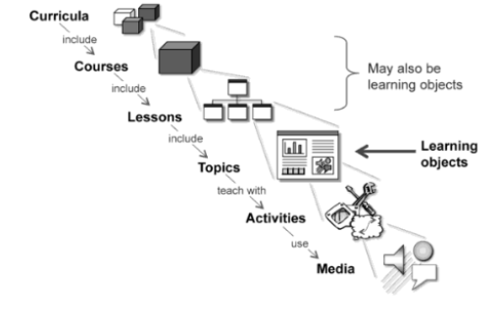

Figure 1: E-learning design techniques byHorton, W. (2011)

* **Curricula** are the programs that include related courses that lead to a degree or certificate in a subject area. The curriculum is typically composed of courses, each of which teaches a broad but specific area of a subject.
* **Courses** are composed of clusters of smaller components called lessons. Each lesson is organised to accomplish one of the broad objectives of the course or a set of objectives.
* **Topics** are each designed to accomplish a single low-level learning objective.
* **Learning activities** are activities designed to provoke a specific learning experience.   
  Each activity may answer a specific question or make a point, but no single activity is sufficient to accomplish a learning objective.
* **Activities** used to measure learning are called tests.
* **Media** elements are words, pictures, voice, music, sound effects, animation and videos that present activities to learners.

### 2.2.3 Instructional Design Models

These are models used to explain the process used in designing and developing instructions. Some popular models are:

* ADDIE Model
* Merrill’s principle of instruction
* Gagne’s nine events of instruction
* Rapid prototyping model
* Community of Inquiry Model

## 2.2.3.1 ADDIE MODEL

For this study, the addie model will be used in designing and developing instruction. The ADDIE model is a five-stage process that provides guidelines for effective training materials. This is the most popularly used instructional design model. These processes are analyze, design, develop, implementation, evaluate.

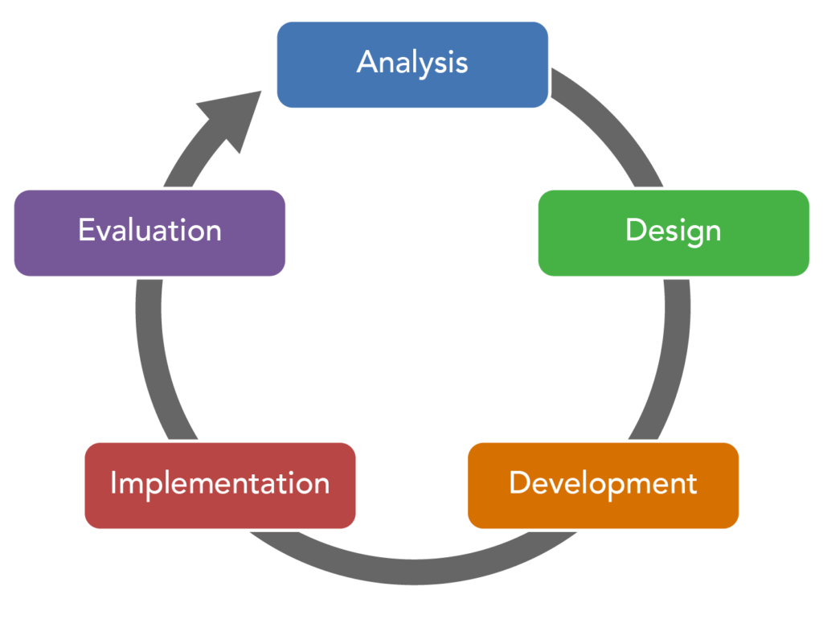

Figure 2: ADDIE MODEL byAthuraliya, A. (2022)

* **Analyze**: The situation is analysed to understand the goals and objectives for the learning material, the requirements, needs, skills, and knowledge of the learners.
* **Design:** Identify the learning objectives, such as the knowledge you want the learners to gain and the learning outcomes.
* **Develop:** Think about how you can help your students reach their predetermined goals and develop a teaching strategy accordingly.
* **Implementation:** Implement the strategies by trying out your training programs with students.
* **Evaluate:** Evaluate and measure the success of the training material you have designed and delivered. Note what needs to be changed.

## 2.3 INSTITUTIONAL ISSUES WITH E-LEARNING

Institutions need to develop a comprehensive strategy and business plan for successful e-learning initiatives. Political factors often have a significant impact on the success of e-learning (Berge, 2001).

Institutional funding and resources for the delivery and maintenance of e-learning are extremely important. Therefore, e-learning must be fully supported and aligned with the institution's mission and strategic plan. E-learning initiatives require orchestration of personnel with diverse skills sets (Belanger & Jordan, 2000).

According to (*Khan, B. 2005),* the main issues of eLearning are in the areas of Administrative affairs, Academic affairs and Students Services.

**Administrative Affairs** These encompass issues related to needs assessment, readiness assessment, organisation and change, budgeting, marketing, financial aid, recruitment, program and courses, admission, tuition and fees, academic calendar, transcripts, registration and payment and grades.

**Academic Affairs** Accreditation, policy, instructional quality, faculty and staff support, class size, workload and compensation, and intellectual property rights.

**Student Services** Pre-enrollment services, orientation, faculty, and staff directories, advising counselling, learning skills development, services for students with disabilities, library support, bookstore, tutorial services, mediation and conflict resolution, social support network, students newsletter, internship and employment services, alumni affairs, and other services.

## 2.4 POPULAR E-LEARNING PLATFORMS

Some popular e-learning platform available includes:

* **Udemy (**udemy.com), one of the most popular online learning platforms, has more than 20,000 experts, with about 12 million students taking a course. With a 10+ million active student database, Udemy ranks first as the best e-learning platform. (Keegan, L. 2021).
* **Coursera (**coursera.org) is an online learning platform offering thousands of learning programs from courses to specialisations and degrees. It works with top Universities and Organizations to facilitate its online courses. Its courses are flexible, affordable, job relevant and recognized by future employers. (Cooke, C. 2022).
* **Skillshare (**Skillshare.com) is an online learning community with thousands of creative people on topics including video, photography, design, and more. It is a digital platform with more than 5 million users and 35,000 courses (Wood, W. 2022).
* **Teachable (**teachable.com), another platform, offers more than 20,000 online courses. They have around three million students (Keegan, L. 2021).

Other platforms include Ruzuku, Academy of mind, and Skillshare, with their tutors earning up to $40,000 per year. A total revenue generation of $47 billion was recorded by online learning platforms, reflecting that most users prefer e-learning (Forbes, 2020).

## 2.5 LEARNING MANAGEMENT SYSTEM (LMS)

Did you know that about 83% of businesses use an LMS today? In fact, the global learning management system market is expected to reach $23.21 billion by 2023 (Robinson, S, 2018, ADT). However, as technology evolves, questions continue to arise as to whether LMS is dead. A recent survey by ATD (Association for Talent Development) found that most respondents (73%) said their LMS use had increased over the past two years, suggesting that LMS use is increasing rather than stagnant. Learning management systems can also provide students with opportunities to use interactive features such as threaded discussions, video conferencing, and discussion boards.

According to Brush, K. (2019), LMS is a system designed to make life easier for those in charge of training and development. It is an application that provides a framework that accepts all aspects of learning to take place. It provides an online classroom for teachers and students. It can also be used for extended enterprise training purposes as well like customer and member training. Customer training is common in software and technology companies that need to teach users how a system works before using a new product. He believes these trainings help in improving interaction with the user and help in improving customer experience and satisfaction.

A learning management system (LMS) may also be referred to as a course management system (CMS) or virtual learning environment (VLE). These can be provided via a portal but can also be provided separately. An LMS is the platform which deploys and manages learning content. It is a software package which:

* Manages courses and course registration.
* Manages course information, course scheduling (timetabling) and administration.
* Provides access to learning.
* Tracks student registration, access and progress.
* Produces learning reports.
* Provides tools to communicate with other learners (collaboration tools).
* Provides access to online help.
* Provides personal space for learners to store learning materials (eLearnity, 2000).

The LMS can be used to assign the necessary courses to current employees to ensure they are developing effective job skills, remain informed about product changes and maintain relevant knowledge through new product and compliance training. Some popular LMS used are Moodle, Adobe Captivate Prime, iSpring Learn, Blackboard Learn, Docebo LMS, TalentLMS, eFront.

### 

### 2.5.1 Uses of LMS

1. Creating and delivering online courses
2. Tracking employee performance
3. Easily tracks learner progress and performance.
4. Facilitates communication and collaboration
5. Selling online courses
6. Organises eLearning content in one location

### 

### 2.5.2 Features of LMS

1. Simple and easy to use
2. Accessible by anyone anywhere
3. Offers interactive learning
4. Creates a collaborative environment
5. Secure and reliable

### 

### 2.5.3 Types of LMS

The different types of LMS deployment options according to Brush, K. (2019) are:

1. Cloud-based LMS
2. Self-hosted LMS
3. Desktop application LMS
4. Mobile application LMS

**Cloud-based LMS** are hosted on the cloud and often use software as a service (SaaS) model. The cloud administrators take care of maintaining the system and performing any technical updates or upgrades. The users can access the system from any location and at any time.

**Self-hosted LMS** require software to be downloaded by the user. The self-hosted platform provides greater creative control and customization, but users must maintain the system themselves and often must pay for updates.

**Desktop application LMS** are installed on the user's desktop.The application may still be accessible on multiple devices.

**Mobile application LMS** can be accessed through mobile devices. This platform deployment type allows users to engage with and track their online learning initiatives on the go.

## 2.6 REVIEW OF EXISTING E-LEARNING METHODS

E-learning has made an enormous growth in education in recent years and its benefits and efficiency makes learning simplistic and easy with little to no stress involved. But it cannot be fully utilised because schools and users have not fully accepted the use of the system. The success of implementation of e-learning depends on whether or not the users and schools are willing to adopt and accept it. Thus, it has become imperative for practitioners and policy makers to understand the factors affecting the user acceptance of web-based learning systems in order to enhance the students’ learning experience (Tarhini A. 2014).

One reason why schools do not accept the e-learning methods is because e-learning is not very suitable for pedagogy. All teachers and lecturers have different methods of teaching and it is difficult for their teaching methods to be implemented through e-learning. The successful implementation of e-learning tools depends on the perception of the users and also their knowledge and skills in using computers. Such major factors have been shown to affect users’ initial acceptance of computer technology and their future behaviour regarding the usage of web-based learning systems (K. Kim and J. Moore, 2005).

### 2.6.1 Technology Acceptance Model (Tam)

Technology acceptance Model is a model that shows how users were able to accept a particular technology. Many researchers have used the TAM to measure students’ acceptance of e learning platforms. (K. Amoako-Gyampah, 2007) found that the perceived ease of use (PEOU) has a direct and positive influence and effect on the intention to use the system.

However, (T. Chesney, 2006) concluded that perceived ease of use did not have a significant influence on the intention to use the system . He pointed out that many of the users engaged were mainly interested in the fun part rather than in productivity. His study showed that perceived usefulness(PU) has a stronger effect on intention to use than perceived enjoyment, and that perceived ease of use has a slightly negative direct effect. Clearly an appreciation of the intervening variables' perceived usefulness and perceived enjoyment (PE) is essential to an understanding of the relationship between perceived ease of use and intention to use.

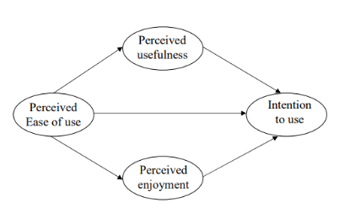  
Figure 3: Technology Acceptance Model byChesney, Thomas (2006)

The results showed that perceived ease of use has a negative effect on users as users don't receive the same level of ease they expect. Perceived usefulness was found to be the most influential variable in predicting the intention to use the web-based learning system in the TAM model.

### 2.6.2 Sapana Patel’s E-Learning System Using The Application Of Instructional Design

Patel S. et al, (2018) developed an e-learning system using the application of an instructional design framework (ADDIE) model in the development and evaluation of e-learning modules as one strategy among a multifaceted approach to the implementation of individual placement and support (IPS), a model of supported employment for community behavioural health treatment programs, in New York State. Three IPS modules were designed and it provided an assessment of learning needs that informed successive modules. All modules were disseminated and evaluated through a learning management system.

Summative evaluation revealed that learners rated the modules positively, and self-report of knowledge acquisition was high (mean range: 4.4–4.6 out of 5). About half of learners indicated that they would change their practice after watching the modules (range: 48–51%). All learners who completed the level 1 evaluation demonstrated 80% or better mastery of knowledge on the level 2 evaluation embedded in each module. In conclusion, instructional design approaches such as ADDIE may offer implementation scientists and practitioners a flexible and systematic approach for the development of e-learning modules as a single component or one strategy in a multifaceted approach for training.

### 2.6.3 Implementation Of Learning Materials Using Debattista’s Comprehensive Rubric For Instructional Design

A study was performed by Daniels M. et al. (2019) to gather and analyse students' perception on implementation of e-learning materials. A sample size of 80 students from private and 80 students from public higher institutions were randomly selected. A semi-structured questionnaire was prepared based on Debattista’s comprehensive rubric for instructional design in e-learning.

The questionnaire prepared in this study is intended to measure the importance of each of the specific standards of elearning as perceived by students. Results showed that all items in Debattista ‘s rubric are indeed relevant in the development and implementation of an e-learning environment as perceived by students.

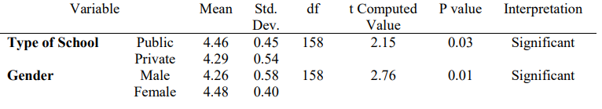

Figure 5: A table demonstrating Impact of learning materials of students by Daniels M. et al. (2019).

Mean rating of each is above 4, with openness, resolution and interface having the highest mean of 4.48. This means that respondents believe that technical infrastructure used to deliver the teaching and learning has to be procured and implemented according to open standards and formats that maximise the value for money and the range of options to fulfil the learning outcomes and the academic needs of faculty and learners, which is openness.

The table above shows that the mean ratings from public school respondents is higher than those from private school. This may imply that respondents from public schools have higher expectations in e-learning than those from private schools. Gender was also used as a factor in determining the level of difference among the responses with regards to Debattista’s rubric.The table shows that female respondents have higher mean than male respondents.

In conclusion, Debattista’s specific standards are highly accepted by students as relevant factors to be considered in the development and implementation of an e-learning environment. There is a significant difference between ratings from public and private institutions. Students of public institutions show higher expectations on e-learning than students from private institutions. Moreover, there is a significant difference between ratings of male and female students which may be due to respondents’ attitude toward learning when devices are involved.

### 2.6.4 A survey on E-learning in Africa

Unwin, T. (2008), wrote a report on a survey on E-learning in Africa, the report is based on 316 responses. 25% of the responses were female while 75% were male. 72% of the responses said that they used an e-learning approach while 78% used blended learning approaches.

In terms of availability of electricity, computers and the internet, 37% of respondents mentioned that they had regular supply of electricity and 39% said they had irregular supply. Others responded to using other alternative forms of electricity like solar power, hydro-electric, wind or had no power supply at all. In terms of computer availability, only 6% of respondents claimed that they had no access to computers, either personally, at work or their institutions. 66% of respondents claimed that their connectivity was at least adequate.

The conclusions drawn up from the survey were that:

* There are wide variety of e-learning practices in Africa
* E-learning is still very much in its infancy across most parts of the continent
* There is much enthusiasm amongst respondents for developing the potential of e-learning in their countries.

### 

### 2.6.5 Challenges for teachers during COVID-19 and how they responded to Online learning

Sindhya, V. (2022), performed a survey across Kerala, India, to understand how teachers are adjusting to online teaching during the COVID-19 pandemic. This survey method was on a sample of 120 teachers and the findings revealed that 96.66% of the teachers have difficulties in conducting online classes as effective as the regular mode of instruction due to the connectivity problems and pacing of lessons by all students. Four teachers mentioned the positive aspects of online classes and that they could manage the classes well, as all students were from urban areas and children of educated parents. Compatibility issues were noticed by 81.66% of teachers.

85% of teachers raised their concern over the emotional stress and anxiety as a result of the students being locked up in their homes.

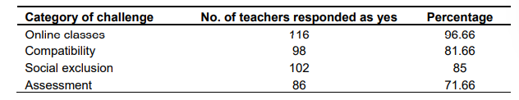

Figure 5:. Result from a survey taken on various teachers on e-learning challenges by Sindhya, V. (2022)

It is suggested to apply well designed learning structure, proper guidance and monitoring of student learning, frequent interaction with parents, blended learning opportunities, low teacher student ratio, resource sharing among teachers, reducing content overload, transparent online assessment tools and strategies, opportunities for creative expression of students, regular interaction with counsellors for meeting psychological issues, ensuring safe and effective use of internet and the team based learning for making the education during the pandemic, more effective.

## 2.7 E-LEARNING APPLICATIONS AND THEIR STATS

|  |  |  |  |  |
| --- | --- | --- | --- | --- |
| **Application** | **Method Used** | **No of Courses** | **Visits (Dec. 2022)** | **Revenue in 2022** |
| Coursera | Self-paced learning | 5,400 courses | 51.4M | $383.6M |
| Udemy | Self-paced learning | 185,000 courses | 102M | $490.3M |
| Blackboard | Blended learning | - | 70.2M | $673.1M |
| Canvas | Blended learning | - | 6M | $10.6M |
| Moodle | Blended learning | - | 2.6M | $34.5M |
| Duolingo | Game-based learning | 102 languages | 37M | $250M |
| Kahoot | Game-based learning | 100M games | 41M | $63.9M |
| Classroom | Collaborative learning | - | 67.0K | $5M |
| Schoology | Collaborative learning | - | 54.1M | $28.5M |
| Pluralsight | Microlearning | 7,000 courses | 5.7M | $210M |
| edX | Self-paced learning | 5,500 courses | 13.0M | $113.4M |
| Codecademy | Game-based learning | 100+ courses | 8.0M | $99.6M |
| Skillshare | Project-based learning | 30,000 courses | 7.3M | $143.5M |

Table 1: E-learning applications and their stats

(Sources: similarweb.com, growjo.com)

## 2.8 SUMMARY OF LITERATURES

|  |  |  |  |
| --- | --- | --- | --- |
| **Author/Research** | **Method/Technique** | **Results** | **Limitations** |
| Perveen, A. (2016). Synchronous and asynchronous e-language learning: A case study of virtual university of Pakistan. | Observation, collection of students’ opinions via a structured questionnaire and student’s discussion on asynchronous modes on the Graded Discussion Board. | 82% of the participants favoured synchronous mode whereas about asynchronous mode 57% responded positively. 62% (n=578) were in favour of a blend of synchronous learning and asynchronous learning and 1% (n=9) were in favour of synchronous learning. | Even though the questionnaires had over 4625, there were only 20 basic questions about English language and its relationship with Synchronous and asynchronous learning. |
| Unwin, T. (2008), A survey on E-learning in Africa | 316 responses. 25% of the responses were female while 75% were male. 72% of the responses said that they used an e-learning approach while 78% used blended learning approaches. | E-learning is still very much in its infancy across most parts of the continent. There is much enthusiasm amongst respondents for developing the potential of e-learning in their countries. The respondents also cited the lack of infrastructures, and need for appropriate training and the cost of implementation. | This survey was on a relatively small sample of Africans who by their very presence on the e-Learning Africa database are already actively interested in e-learning. |
| Daniels M. et al. (2019) Students’ perception on e-learning | Implementation Of Learning Materials Using Debattista’s Comprehensive Rubric For Instructional Design. | A sample size of 80 students from private and 80 students from public higher institutions were randomly selected. Mean rating of each is above 4, with openness, resolution and interface having the highest mean of 4.48. | The system lacks a rubric for grading answers. There is no real-time interaction like a chat-box between student and teacher for a faster consultation. Teachers should be notified when offline. |
| Patel S. et al (2018), Sapana Patel’s E-Learning System Using The Application Of Instructional Design. | E-learning system using application of an instructional design framework (ADDIE) model. | It revealed a high knowledge acquisition (mean: 4.4–4.6 of 5). About half of learners indicated that they would change their practice after watching the modules (mean: 48–51%). All learners who completed the level 1 evaluation demonstrated 80% or better mastery of knowledge on the level 2 evaluation embedded in the module. | The inability to use validated scales to assess knowledge, practice, and readiness, differences in sample sizes which prevent examining a stable group of learners over time, and difficulties determining the direct impact of the e-learning modules on employment outcomes due to the presence of other elements in the initiative. |
| Emmanouilidou et al., 2012. Comparison between synchronous and asynchronous instructional delivery method of training programme. | Forty nine in-service elementary physical educators with teaching experience, were randomly divided into synchronous, asynchronous, and control groups. | Before their participation in the program, students answered about 40% of the questionnaire correctly. The post-test showed that both experimental groups answered correctly an average of 62% of questionnaire items, meaning a percentage of knowledge improvement of 52% and 59% for the synchronous and asynchronous instructional group. | The fact of voluntary participation of the programme’s attendants. Participation of teachers in such a programme could result in different outcomes. The fact that participants were from schools of Northern and Central Greece. It is possible that a larger sample with physical educators from all over the world would yield different results. |
| T. Chesney (2006), An acceptance model for useful and fun information systems | Technology acceptance model. | He concluded that perceived ease of use did not have a significant influence on the intention to use the system and that perceived ease of use has a negative effect on users as users don't receive the same level of ease they expect. Perceived usefulness was found to be the most influential variable in predicting the intention to use the web-based learning system in the TAM. | It does not take into account social norms and peer pressure, which can also affect technology adoption. TAM is not designed to address the use of technology in businesses, universities, and organisations, but is designed primarily for awareness and purpose. |
| Challenges for teachers during COVID-19 by Sindhya, V. (2022). | This survey method was on a sample of 120 teachers. | The findings revealed that 96.66% of the teachers have difficulties in conducting online classes as effective as the regular mode of instruction due to the connectivity problems and pacing of lessons by all students. Compatibility issues were noticed by 81.66% of teachers. 85% of teachers raised their concern over the emotional stress and anxiety as a result of the students being in their homes. | Proper strategies were not available to make a transparent online evaluation to the mass and the survey size was limited. The survey was only conducted in one location (Kerala, India). Results might be different in location with different internet accessibility. |

## Table 2: Summary of literatures

## 2.9 CONCLUSION

The literature on e-learning has consistently shown that it can be an effective way to facilitate learning and improve student outcomes. This is particularly true when e-learning is used in conjunction with traditional face-to-face instruction, as it allows for more individualised instruction and flexible learning environments. Research has also indicated that e-learning can be beneficial for students with diverse learning needs, as it allows for personalised instruction and the use of technology to support different learning styles. Additionally, e-learning can be cost-effective and can provide access to education for students who may not have access to traditional classroom settings.

However, the effectiveness of e-learning also depends on the quality of the instructional materials and the support provided to students. Poorly designed e-learning courses and inadequate support for students can lead to negative outcomes, such as low levels of engagement and motivation.

Overall, the literature on e-learning suggests that it can be a valuable tool for facilitating learning, but its success depends on the design and implementation of the instructional materials and the support provided to students. E-learning has too many disadvantages to be the main standard of learning. Traditional learning should be the base for learning while E-learning can be used in the form of support or a blended learning approach should be used.

**CHAPTER THREE**

# **METHODOLOGY**

The methodology of e-learning involves the use of technology, such as online platforms and digital content, to deliver educational content to learners in a flexible and convenient manner. This approach allows learners to access the material at their own pace and from a variety of locations, enabling them to learn at their own convenience.

To implement e-learning effectively, educators must first identify the goals or learning objectives and desired outcomes of the course or training program of the course and determine the appropriate technology and tools to use. This may involve creating engaging and interactive content, such as videos, simulations, and interactive activities, to enhance the learning experience. Additionally, educators must provide support and guidance to learners throughout the course, such as through online forums and regular feedback on progress. This helps learners to stay engaged and motivated, and ensures that they have the necessary support to succeed.

## 3.1 FRAMEWORK OF THE E-LEARNING SYSTEM

**Main Page:** This is the landing page for the web page that the user is directed to after clicking on or typing in the link. The purpose of the landing page is to convince the user to take a specific action, such as signing up or filling out a form, making a purchase, logging into their accounts. It contains a navigation bar and this navigation bar includes links to the login page and the sign up page. There is also a learn more button and from there, the users will be able to get more information about the web application.

**Sign Up Page:** The signup page is a web page that allows users to create an account on the web application. It requires the user to provide personal information such as theirfirst name, last name, email, password and select the option of whether they are students or not. If the user selects yes, they can enter their matriculation number, faculty, department and level. The latter fields are optional. The database will receive these details and store them for later retrieval. Duplicate registration for a certain matriculation number or email is not allowed. Once the user has completed the signup process, they will be able to access the features and services of the web application using their newly created account. The purpose of a signup page is to enable users to create an account and become a member of the website or application.

**Login Page:** A login page allows a user to enter their username or matriculation number and password in order to access the main features of the web application. Once the user has entered their credentials and clicked the "login" button, the application will verify their identity and grant them access to the features. The purpose of a login page is to provide a secure way for users to access the site or application and to protect their personal information and data.

**Learn More:** The learn more page provides additional information about specific topics. This will contain a FAQ (Frequently Asked Questions) section that provides answers to questions that are commonly asked by users, give details about the e-learning project and its purpose, and a section which will contain information on where to get support. This page also contains contact details and links related to Lagos State University (LASU) that users can contact for assistance and information regarding the university. These include links to the school's website, Instagram, Facebook and Linkedin pages, along with a map and address location of the school.

**Dashboard**: When the user logs into their account, they will be able to access their dashboard which contains a visual display of the user’s data. Dashboard pages are often used to track key performances and other metrics that are important to the success of the learner or user, and they can be accessed by different users to monitor and track progress on various projects or courses. Some features of the dashboard page include the notifications for alerts and messages, a calendar, and a search bar.

**Search:** It is a web page that allows users to search for specific information or content and materials about the courses within the website. When a user enters a search query into the search field and submits it, the search page displays a list of results that match the search criteria. The results include the course code, course title, level and link to the material’s web page.

**Edit Profile:** An edit profile page allows users to make changes to their personal information and settings on the web application. This includes updating their first name, last name, matric number and password. The user is not allowed to change their email address in this section. There will also be an option available for the user to delete their account. The account will be permanently erased from the database. The edit profile page is used to keep a user's personal information up to date and to make changes to their account preferences.

**All courses:** In this page, the user will be able to view all available courses and add courses to their preferences. It will contain a list of all the courses in the database, with their course code, course title, level and an image representing the course. Within this, they will be able to read the courses and download the materials.

**My courses:** This contains a list of all the courses that the user has enrolled for. The user will be able to easily locate all the courses they have shown interest in instead of searching for them every time.

**Take Test**: In this section, the user will be able to take a short test on a particular course to test their knowledge and work on improving. The answers to the test questions are revealed at the end.

**Log Out**: Log out page is a feature of a web application that allows a user to end their current session and log out of their account. When a user clicks the logout button, they are redirected to a logout page that confirms that they have been logged out and provides them with the option to log back in if they want to continue using the service. The main purpose of a logout page is to allow users to securely end their session and protect their account from unauthorised access. When a user logs out, the website or application typically terminates the session and clears any session tokens that were used to identify the user. This helps to prevent someone from accessing the user's account if they leave their device unattended or if someone else tries to use their device after they have logged out.

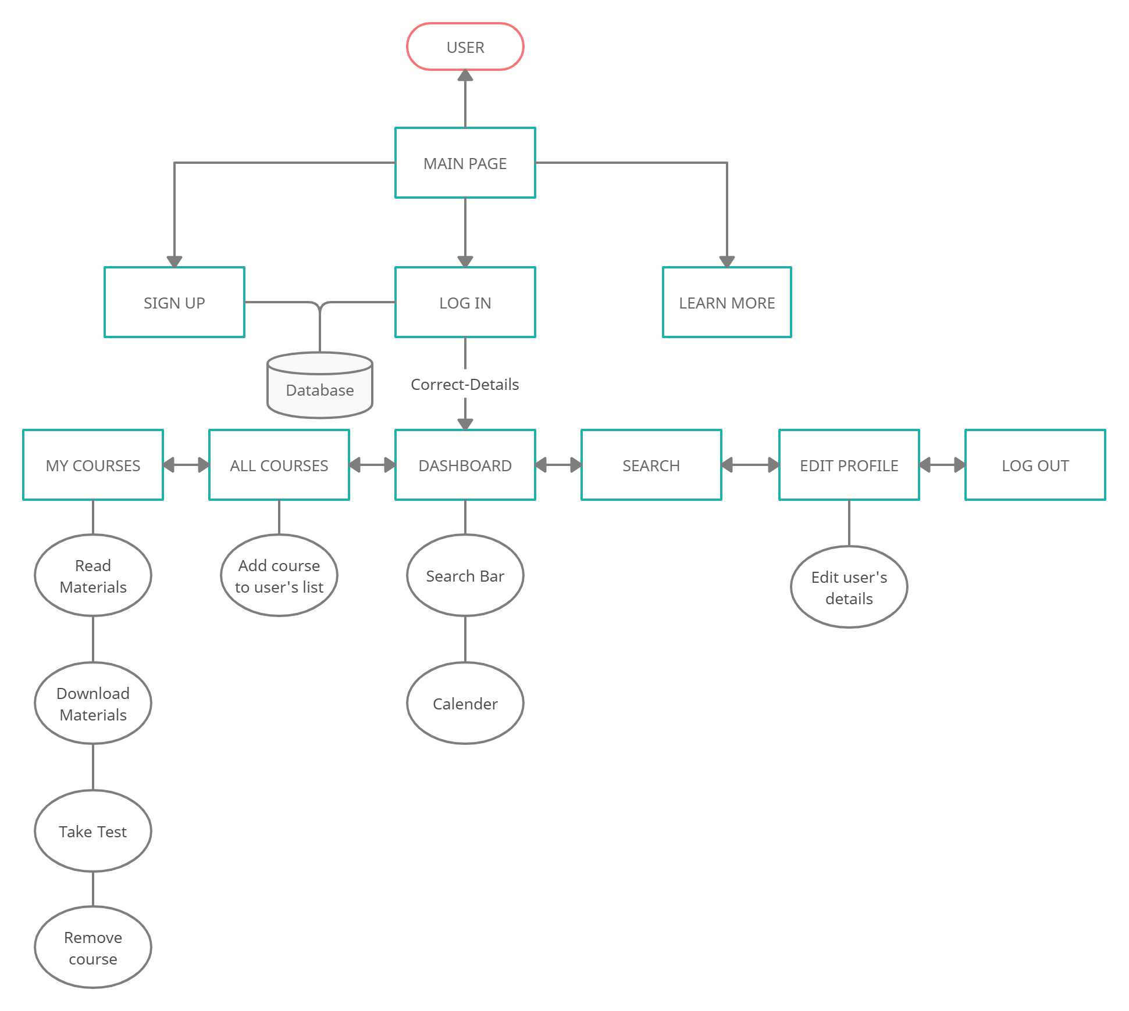

Figure 5: Framework of the E-learning system

## 3.1.2 PHASES OF USER INTERACTIONS

1. **Initial landing**: The user arrives on the web-app's homepage and is presented with an overview of the features and services offered.
2. **Sign-up**: The user creates an account on the web-app and provides necessary personal information.
3. **Login**: The user logs in to the web-app using their email and password or matric number and password.
4. **Navigation**: The user navigates through the webapp's various pages and sections to find the information or functionality they are looking for and learns how to use them. They can check out several courses to read, search for a course to read
5. **Interaction**: The user interacts with the web-app by clicking buttons, filling out forms, or using other features to complete a task or access content.
6. **Feedback**: The web-app provides feedback to the user through on-screen messages, to confirm the completion of a task or to provide additional information.
7. **Error handling**: In the event of an error or issue, the web-app provides guidance or support to the user to help them resolve the issue and continue using the web-app.
8. **Continual use**: The user continues to use the web-app regularly, updating their profile, taking tests, reading and downloading materials.
9. **Logout**: The user logs out of the web-app or exits the browser to end their session.

## 

## 3.2 IMPLEMENTATION TOOLS

## 

## The implementation of this project would be achieved using the following tools:

**3.2.1 Hypertext markup language (HTML 5):** It is a markup language used to structure content on the web. It uses elements and tags that tell web browsers how to display content on the web. It is used to interpret and compose text, images, and other material into visual or audible web pages. Several versions including HTML 1, HTML 2, HTML 3, HTML 4 and HTML 5. HTML 5 is the latest version and is being used in most web applications today.  
  
**3.2.2 Cascading style sheet (CSS 3):** It is a style sheet language used to describe and present documents and texts written in markup languages. These presentation features include layout and fonts, colours, and animation and transition. Adding CSS can improve accessibility, flexibility and give control to the users. Variations of CSS include CSS 1, CSS 2, CSS 2.1 and CSS 3. CSS 3 will be used for this project, it has more features compared to the previous versions and most of its features are supported by the popular and most used web browsers. **3.2.3 Javascript (JS):** It is a scripting language that allows you to update content, manipulate text, control multimedia, and even animate images. JavaScript uses HTML DOM to access and change all the elements of an HTML document. DOM (Document Object Model) is a platform and language-neutral interface that allows programs and scripts to dynamically access and update the content, structure, and style of documents. The DOM defines the html elements, properties, methods and events (w3schools.com). Most browsers support all released versions of JS.  
  
**3.2.4 Javascript Object Notation (JSON):** JSON is a general-purpose data interchange format that is defined as a subset of JavaScript's object literal syntax. It is a type of file format that stores and transmits structured data. It is based upon JavaScript syntax and uses basic data types such as strings, boolean, numbers, arrays, objects and null (techquintal.com).

**3.2.5 Hypertext Preprocessor (PHP):** It is a server scripting language used for making dynamic and interactive web pages. It is a free and open source server-side language. The version of php used for the project is php -v 8.1.13. Over 244+ Million Websites use PHP, it is the most popular programming language in the field of web development. PHP has been used by some of the biggest and most successful companies around.

**3.2.6 Bootstrap 5:** It is a popular CSS and JS framework for creating responsive websites. It consists of built-in classes that need to be assigned to a tag in the markup language.

**3.2.7 Visual Studio Code:** This serves as the text-editor and as an Integrated Development Environment (IDE). Visual Studio Code is a source-code editor that can be used with a variety of programming languages including Javascript, PHP, Python. Visual Studio Code also ships with IntelliSense for JavaScript, TypeScript, JSON, CSS, and HTML. Its features include support for debugging, syntax highlighting, intelligent code completion, snippets, code refactoring, and embedded Git. Users can also install extensions that add additional functionality.

**3.2.8** **My Structured Query Language (MySQL):** It is an open-source Relational Database Management System (RDBMS). An RDBMS provides an interface between users, the application and the database. MySQL is the fastest growing open-source relational database management system with 100 million downloads till date.

**3.2.9 Git:** Git is a version control system that allows developers to track changes to source code over time. It allows them to revert back to previous versions of the code if necessary. Git also makes it easier for developers to collaborate on projects, as they can work on separate branches and then merge their changes back into the main branch.

**3.2.10 Ajax (Asynchronous JavaScript and XML):** It is used in creating dynamic web pages. It allows for the exchange of data between the web browser and the server without the need for a full page refresh. This means that users can interact with the page without having to wait for the entire page to reload. Ajax uses a combination of technologies, including JavaScript, XML, and HTTP requests, to create this dynamic behaviour. The JavaScript code sends a request to the server, which then responds with the necessary data.

**3.2.11 XAMPP:** It creates a local host to test websites before releasing it to the main server. It is a platform that furnishes a suitable environment to test and verify the working of projects based on Apache, Perl, MySQL database, and PHP through the system of the host itself. XAMPP comes with a lot of components including Apache HTTP Server, MariaDB database, PHP, phpMyAdmin, FileZilla FTP Server, wordPress. XAMPP v3.3.0 was used for this project.

## 3.3 STAGES FOR IMPLEMENTATION OF E-LEARNING

Epic (1999) provided a comprehensive review of the elements required for successful implementation of an e-learning project. They deem the five key stages as analysis, design, development, implementation, and evaluation.

All of these need to be considered and addressed for success.

* **Analysis stage**: The identification of training needs, specification of learning objectives, selecting and understanding the audience, and deciding on the methods of learning
* **Design stage**: Creation of own bespoke application by selecting content, media, type of interactivity available to learners, and user interface.
* **Development stage**: Putting the design into action which involves production of audio/video, programming of software, authoring of materials, and testing.
* **Implementation stage**: Promoting the programme, collecting management information, and appointing skilled mentors.
* **Evaluation stage**: Reviewing the performance of the programme against its objectives, in terms of take-up, efficiency and effectiveness.

The Epic survey (1999) found at least three-quarters of those surveyed felt that getting the right support and the right technology were particularly important in the success or failure of online learning. Their survey found that support from senior management and attitudes of trainees, other employees, trainers and the IT department were considered very important factors. So too was the availability of sufficient network bandwidth and availability of networked terminals. Also considered important were the suitability of learning content and the general awareness of the benefits of online learning.

## 3.4 IMPLEMENTATION APPROACH

Asynchronous learning is a type of e-learning in which students can access educational materials and complete coursework on their own time, rather than at a set time in a physical classroom. Asynchronous learning can be an effective approach for developing an e-learning web application because it allows students to learn at their own pace and fit their studies into their busy schedules. The students and instructors do not need to be online at the same time in order to participate in course activities. The ways in which asynchronous learning will be implemented are as follows:

1. **Consider the needs of your target audience**: Asynchronous learning is most effective when it is tailored to the needs of your target audience. The main focus of the application is to provide students with the necessary resources and support to enhance their learning skills and abilities. The course content is self-paced, allowing learners to progress through the material at their own speed.
2. **Use a variety of media and interactive activities:** To keep students engaged in an asynchronous learning environment, it is important to use a variety of media and interactive activities. This could include videos, podcasts, readings, quizzes, and discussions. This application involves using a variety of media, such as text, audio, and interactive elements, to engage learners and provide them with the flexibility to learn at their own pace.
3. **Design for self-guided learning**: It relies on students being able to work independently and at their own pace. The implementation of this appl promotes self-learning as there are no time barriers, tests can be taken and corrections are given at the end of each test.

### 3.4.1 Why asynchronous learning is the right approach

Here are the reasons why asynchronous learning is more suitable for the web application:

1. **Flexibility**: With asynchronous learning, it allows learners to access course materials and participate in activities at their own pace, within a certain time frame. This can be particularly beneficial for learners who have busy schedules or who are located in different time zones.
2. **Convenience**: With asynchronous learning, the web application can be accessed from any device with an internet connection, which means learners can participate in the course from anywhere at any time. This can be more convenient than synchronous learning, which requires learners to be present at a specific time and place.
3. **Self-paced learning:** Asynchronous learning allows learners to progress through the material at their own speed, which can be helpful for those who need more time to absorb the content or who have different learning styles.

## 3.5 DATABASE SPECIFICATIONS

A database is a structured collection of data that is stored and organised in a specific manner to allow for efficient retrieval and management. It can be used to store and manage large amounts of information, such as customer records, sales data, or inventory information. Databases can be accessed and managed through software known as a database management system (DBMS).

The database was built using MySQL. The database name for this project is called learning and it consists of 4 tables. The table names are users, courses, dashboard and test.

|  |  |  |
| --- | --- | --- |
| **Column Name** | **Data type** | **Description** |
| Id | int(11) | Primary key of the table Unique number to identify each student |
| first name | varchar(30) | First name of the user |
| last name | varchar(30) | Last name of the user |
| email | varchar(50) | User’s email address |
| matricNo | varchar(9) | User’s matric number (optional) |
| faculty | varchar(30) | User’s faculty (optional) |
| department | varchar(60) | User’s department(optional) |
| level | varchar(4) | User’s level (optional) |
| password | varchar(200) | password of the user |
| mycourse | text | Courses that the user enrols for. |

Table 3 : Users Table

|  |  |  |
| --- | --- | --- |
| **Column Name** | **Data type** | **Description** |
| Id | int(11) | Primary key of the table  Unique number to identify each course |
| Course Code | varchar(30) | Contains the course codes of every course |
| Course Title | varchar(80) | Contains the course titles of every course |
| level | varchar(10) | Contains what level a course is offered in |
| materials | varchar(2000) | A short description of what a course entails |

Table 4 : Courses Table

|  |  |  |
| --- | --- | --- |
| **Column Name** | **Data type** | **Description** |
| questionid | int(11) | Primary key of the table  Unique number to identify each question |
| question | text | It contains a question |
| answer | text | answer to the question |
| options | text | It contains multiple choice options for the question |
| ccourse | varchar(10) | It contains the course code for which that question belongs to |

Table 5: Test Table

|  |  |  |
| --- | --- | --- |
| Column Name | Data type | Description |
| id | int(11) | Foreign key to the table (users). It points to the id of that table. |
| lastRead | varchar(10) | Holds the course code of the course the user read last. |
| lastTest | varchar(10) | Holds the course code of the last test the user took. |
| testScore | int(11) | Holds the score of the last test the user took. |

Table 6: Dashboard table

## 

## 

## 3.6 MATERIALS GATHERING METHODS

Materials and past questions were gathered from several students across all levels in the department as well as from vendors and cyber-cafes on school grounds to obtain materials relating to computer science that they may possess. Several links to webpages and youtube videos that are useful will be provided.

There are several e-libraries that are supported by LASU and its computer science department, three major websites that are promoted by the school’s web page are PDF Drive, freetechbooks.com, and FreeComputerBooks.com. These websites will be utilised in our E-learning platform.

**PDF Drive (pdfdrive.com)**

It is a free search engine which allows you to search, preview and download millions of PDF files into your devices.

**FreeComputerBooks.com**

It is a directory of Hyperlinks to free ebooks, tutorials, and lecture notes, etc, all over the world. They do not own any books but instead provide links to several e-books that are available to read.

**Freetechbooks.com**

It lists free online computer science, engineering and programming books, textbooks and lecture notes, all of which are legally and freely available over the Internet.

**Roadmap.sh**

It is a community initiative to create roadmaps, guides, and other educational content to help developers navigate the way and derive insights in learning. It is not recommended by LASU but is very useful for people coming into the developer world.

**CHAPTER FOUR**

# **IMPLEMENTATION, TESTING AND EVALUATION OF THE SYSTEM**

## 4.1 SYSTEM DESIGN

The purpose of this project is to create the design elements for the e-learning platform that can be used to improve students' access to course materials in Lagos State University and improve the learning process. The proposed system is a web-based system of learning which provides:

1. An efficient and easy learning system that students can interact with.
2. A simple user interface that facilitates the interaction with the system.
3. An elegant description of all courses available and the option for students to download the materials provided.
4. A page for evaluating the learning process through taking quizzes.

The system life cycle goes through the following steps, according to the ADDIE Instructional Model: Planning, Research, Design, Implementation and Testing & Maintenance. During the entire project lifecycle, this model is followed.

## 4.2 SYSTEM REQUIREMENTS

The specifications of the framework for implementing the proposed system are:

### 4.2.1 Server-Side Requirement

* Operational system: Window, UNIX/Linux, MacOS
* Web Server: Apache
* Programming language: PHP, JS
* Database: MySQL
* Disk space on the server: 1GB

### 4.2.2 Client-Side Requirements

* Hardware Specification: Compliant with any smartphone or personal computer
* Operating System: Works smoothly on any device that has a browser
* Browser Support: Opens up on any computer running scripts for PHP and Javascript.

## 4.3 System implementation

The system consists of several modules that have been designed to help the user have easy navigation through the system: These modules include:

### 4.3.1 Landing page

The main page that guides the user to what activity they want to perform.



Figure 6: Landing page of the e-learning system

From figure 6 above, the Get started button takes users to the sign up page, the login button takes the user to the login page, while the learn more button takes the user to the faq and contact page.

### 4.3.2 Sign up page

The user registers an account and the details imputed gets stored in the database.

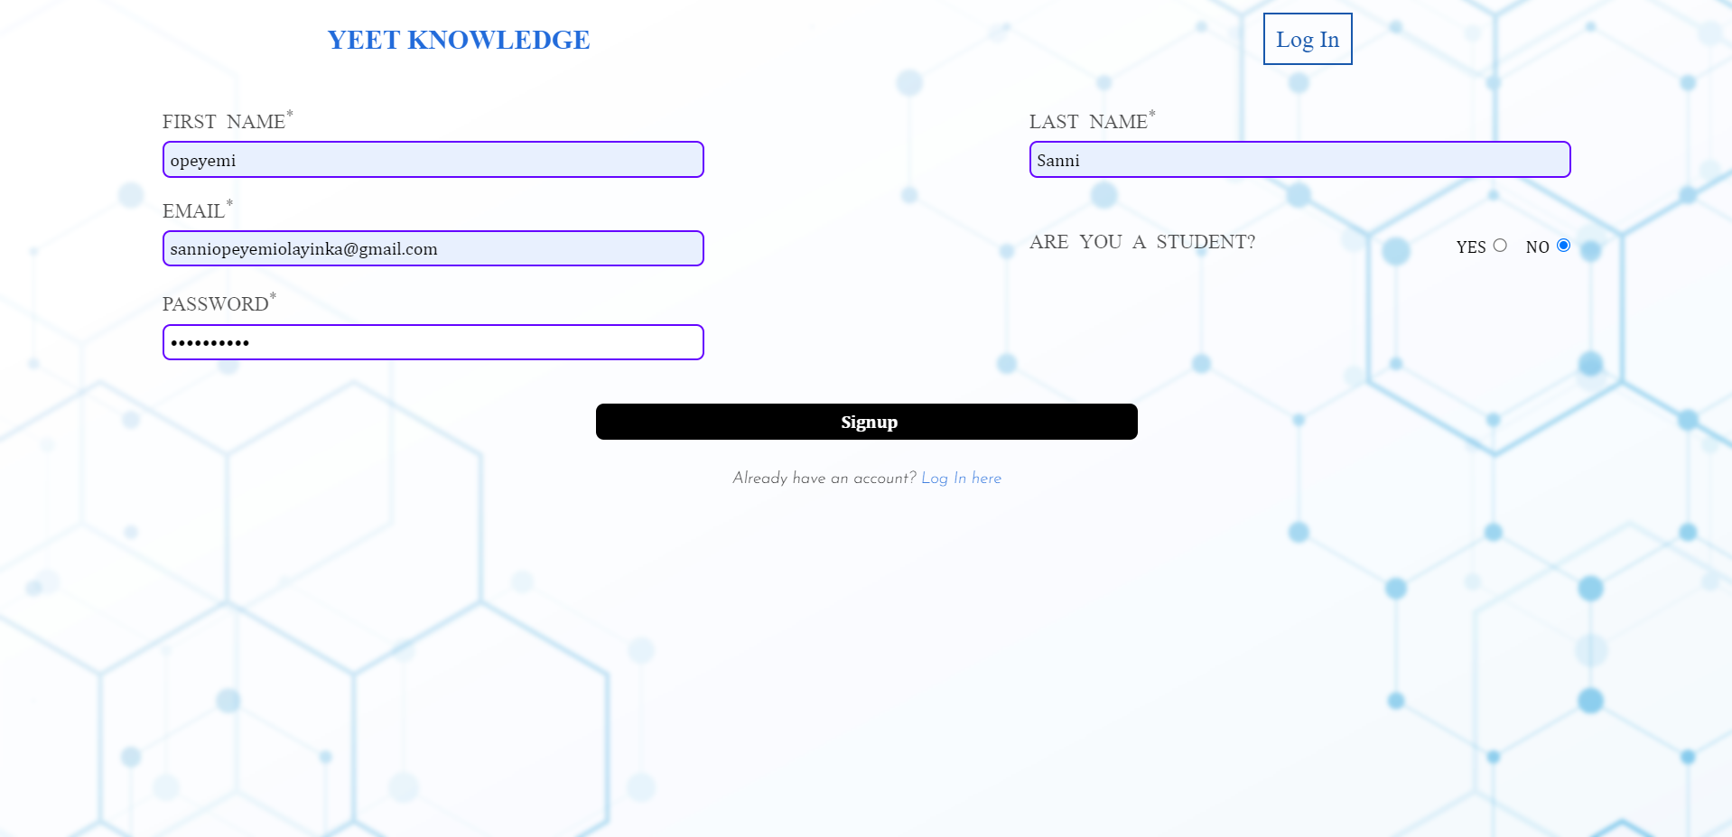

Figure 7: The sign up page

The sign up page also includes an option for users that are students of LASU and wish to input their matric number, level and department. Incase of invalid entries, there are several functionalities for error handling, invalid inputs and duplicate entries. There are certain inputs that are not allowed and an error message appears if such entries are made. The first name, last name, Email and password fields cannot be left blank. The password field cannot contain spaces and must be at least 4 characters long. There are also certain input values that cannot be accepted as passwords. Ex. 0000 is easily predictable and so cannot be accepted. Matric number before 2015 is not accepted ex. 140591001. And numbers after the current year are not also allowed ex. 240501001.

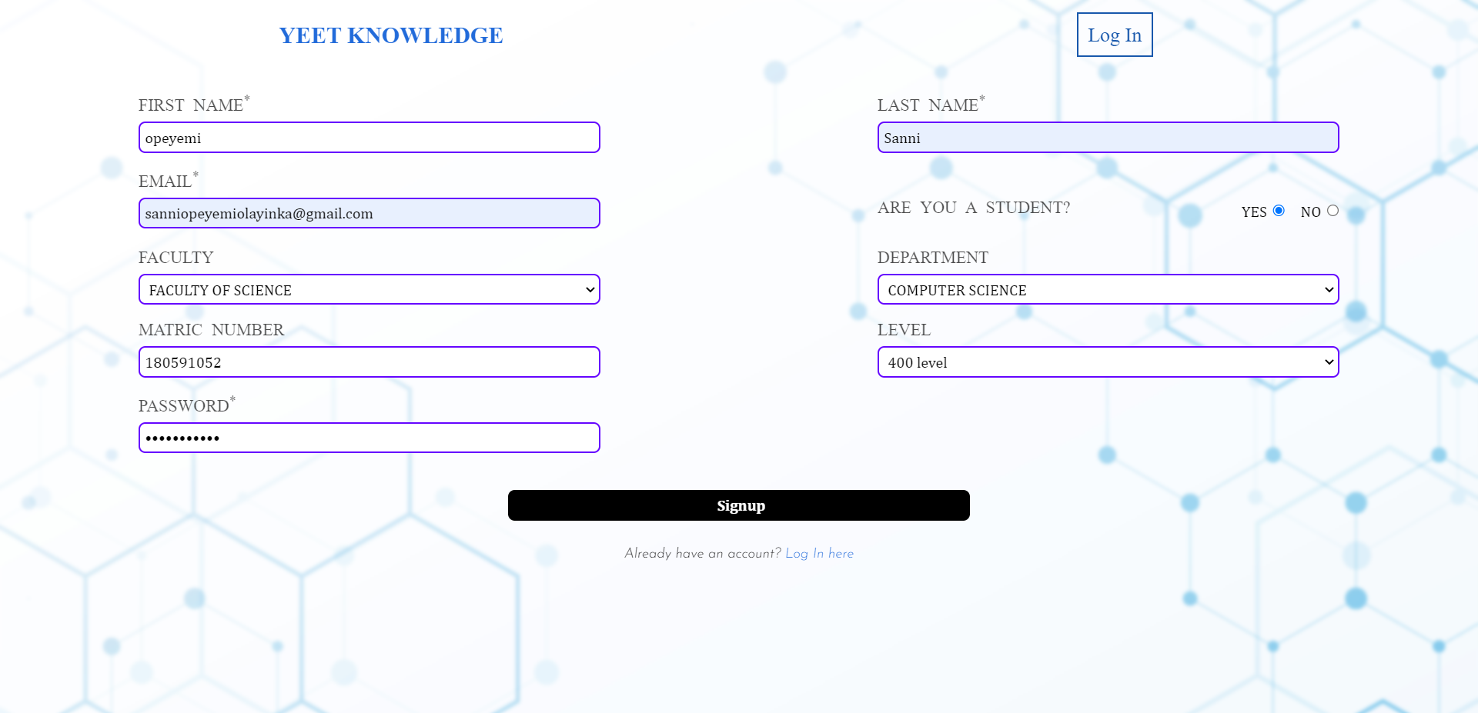

Figure 8: The sign up page with students’ options

### 4.3.3 Login page

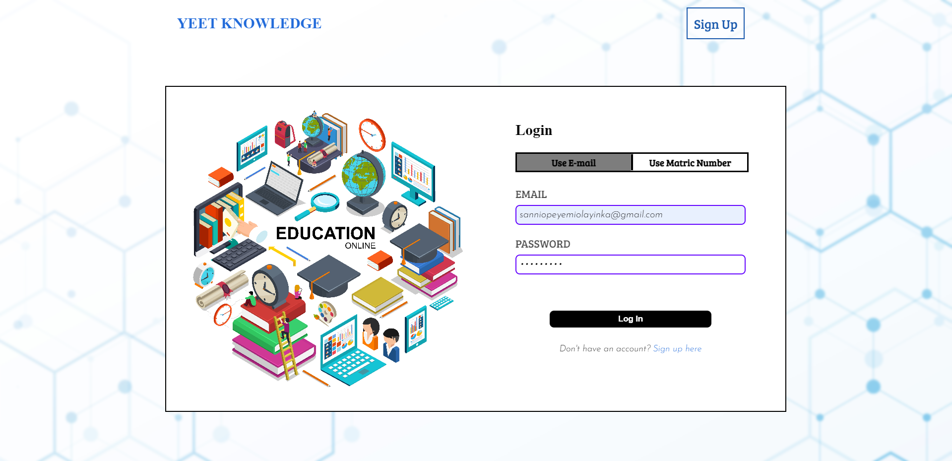

Figure 8: Login page using email

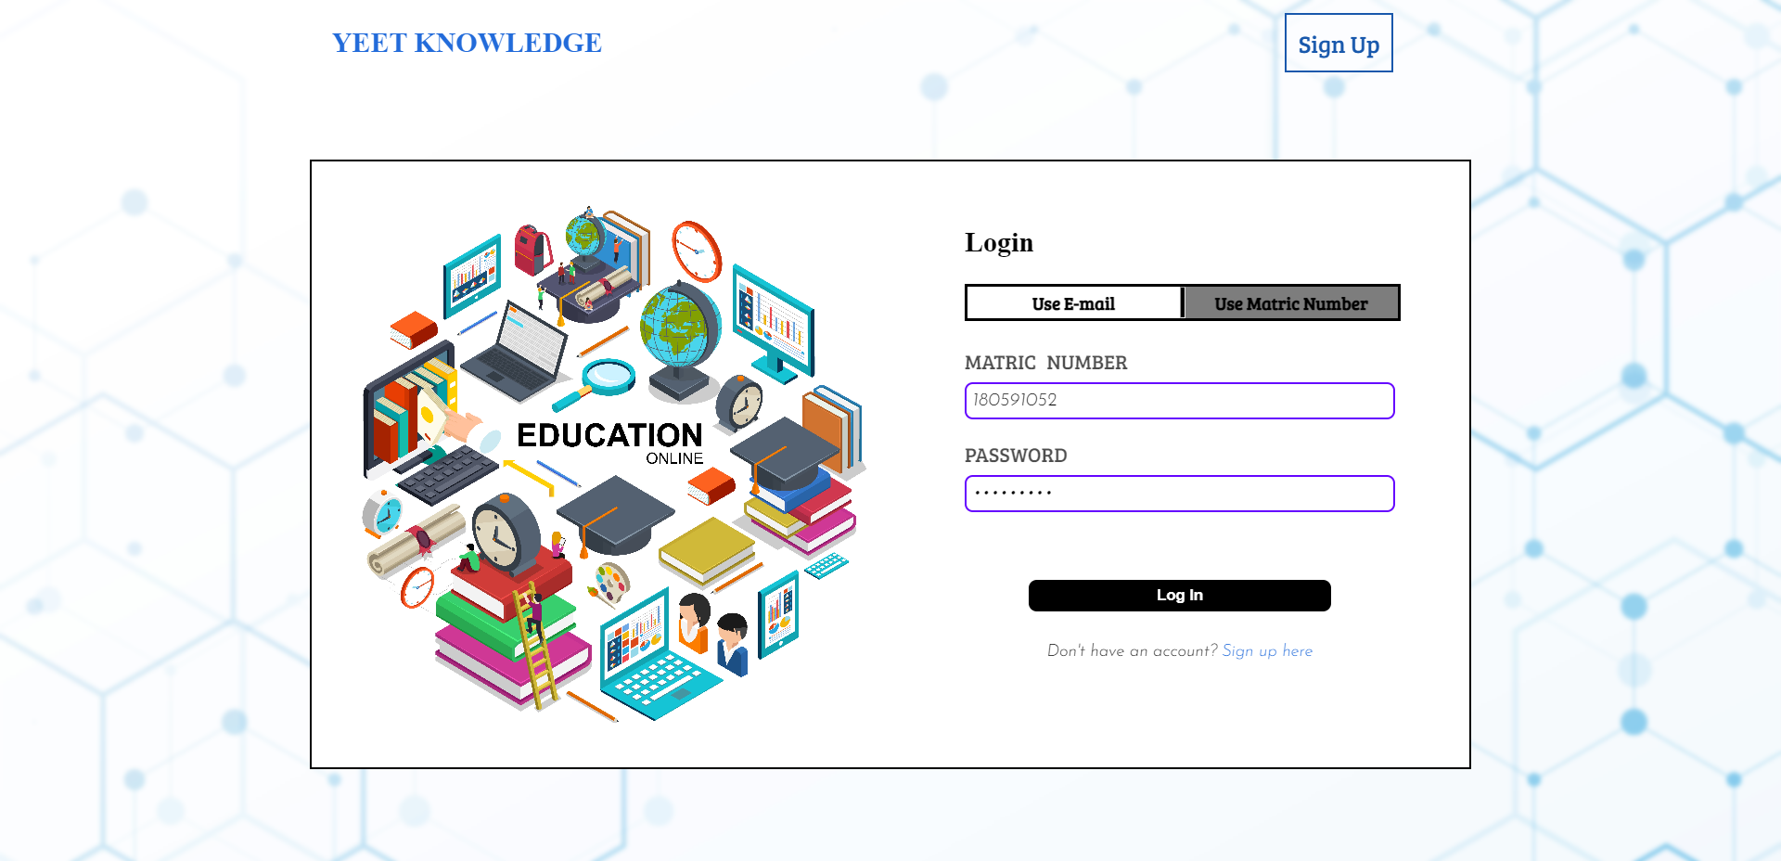

Figure 9: Login page using Matric Number

This is where the user logs into their existing account. There are two ways of logging in, with Email and with matric number.If the details entered here do not match the details given during registration, the user will receive an error.

### 4.3.4 Activities after logging in

There are several activities that the user can perform after they log in. These activities can be viewed on the side navigation bar. This navigation bar contains links to 6 main activities.

1. Dashboard page
2. My Courses
3. All Courses
4. Search List
5. Edit Profile
6. Log Out

#### 4.3.4.1 Dashboard

This is the default page the user sees after logging in. This page contains a section that shows the users’ details, the last course they were reading and the last test they took along with their score in the centre of the page, a calendar and a quote from a famous scientist on the right. If it is a new account and they are yet to read a course or take a test, these will not be visible. The side navigation bar contains several options.

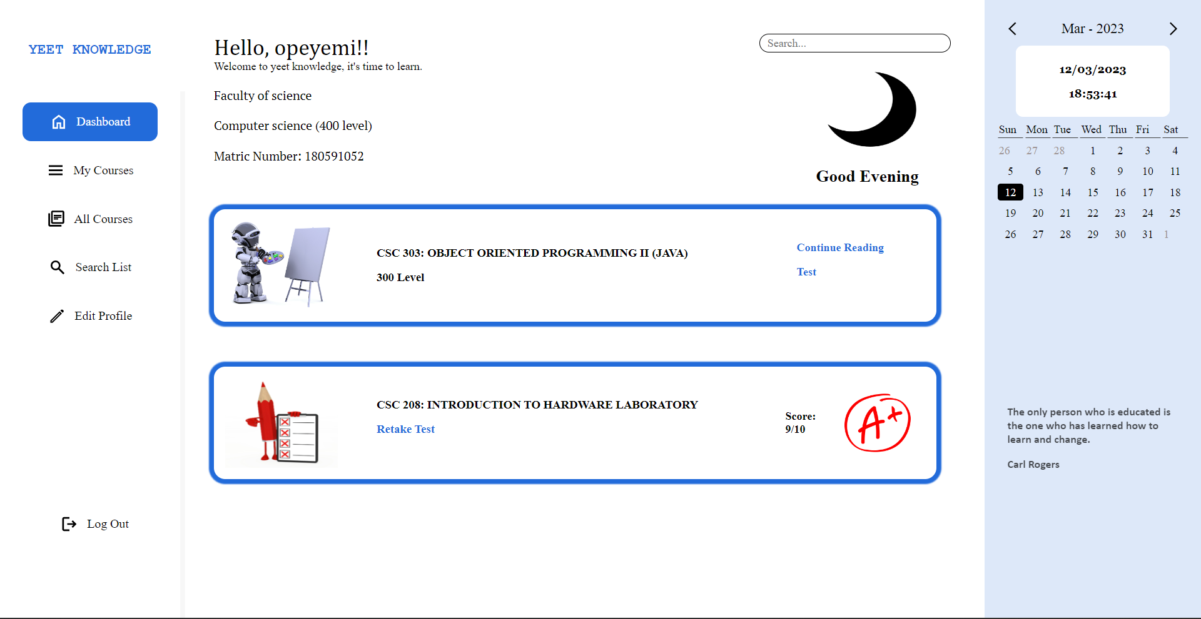

Figure 10: A view of the dashboard page

#### 4.3.4.2 My Courses

This page contains a list of all the courses that the user has enrolled for. It displays the course name, course title and activities the user can perform. These activities includeopening the course page to read materials and download materials, take a test or delete that course from the list of courses. If the user chooses to read a course, the page displays the course details, and course outline from the students handbook as well as materials that can be downloaded. The page also displays a short note about the course and an overview of things the learners should understand.

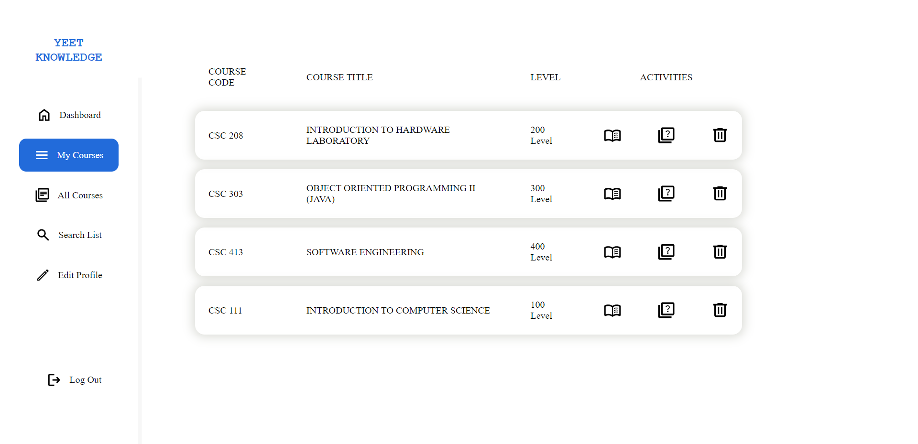

Figure 11: A view of the my courses page

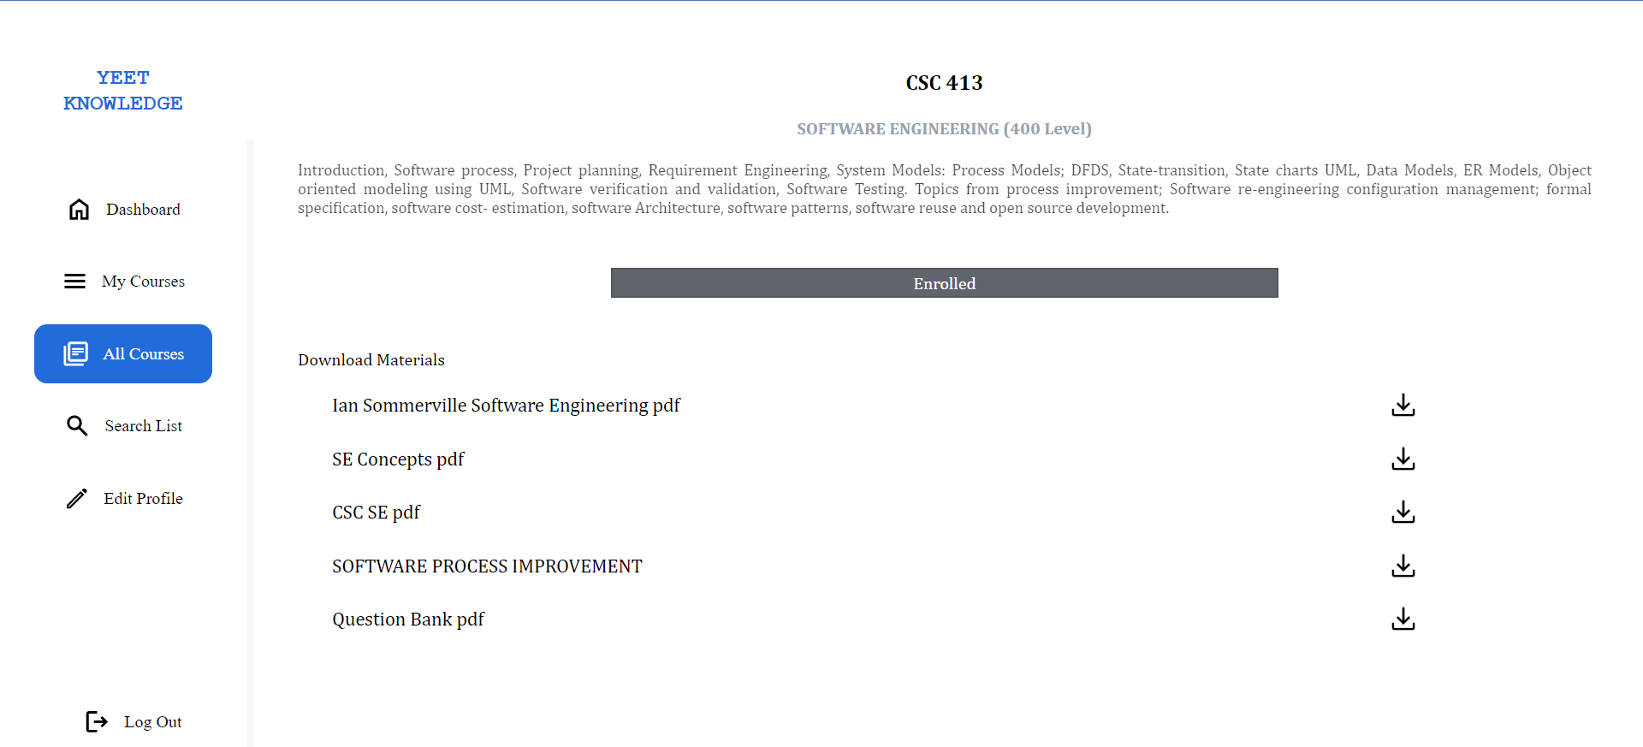

Figure 12: Reading about course (csc 413)

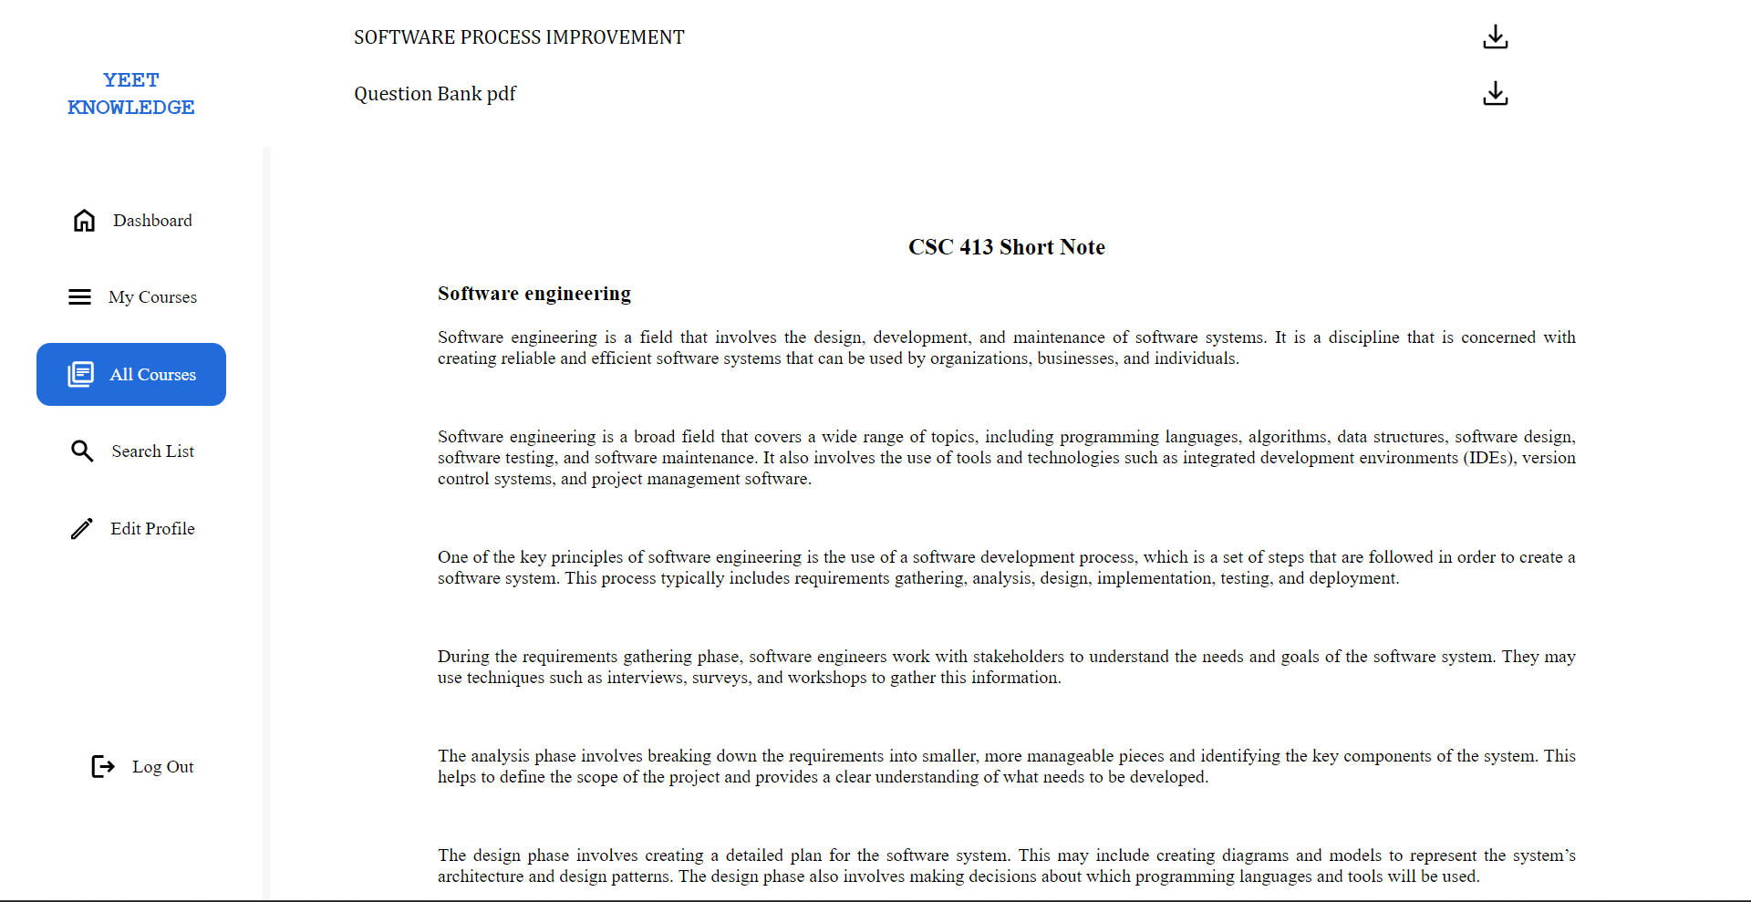

Figure 13: Reading about course (csc 413) and its short note

The user can also decide to take a test to evaluate their knowledge, the test contains 10 multiple choice questions and the answers are revealed at the end of the test.The answers are displayed at the end of the test and the answers that were correctly guessed are highlighted in green while the ones that were incorrect are in red.

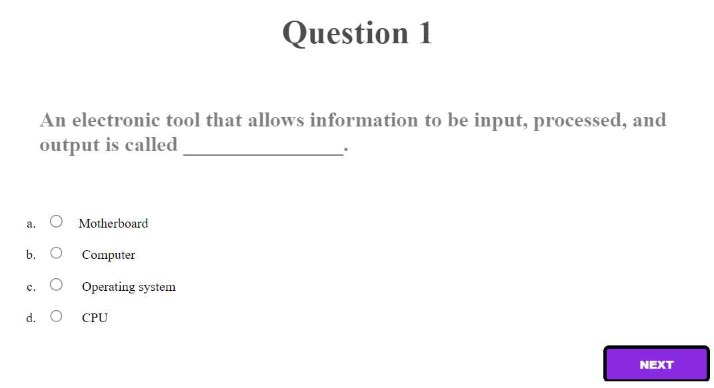

Figure 14: Taking csc 111 test

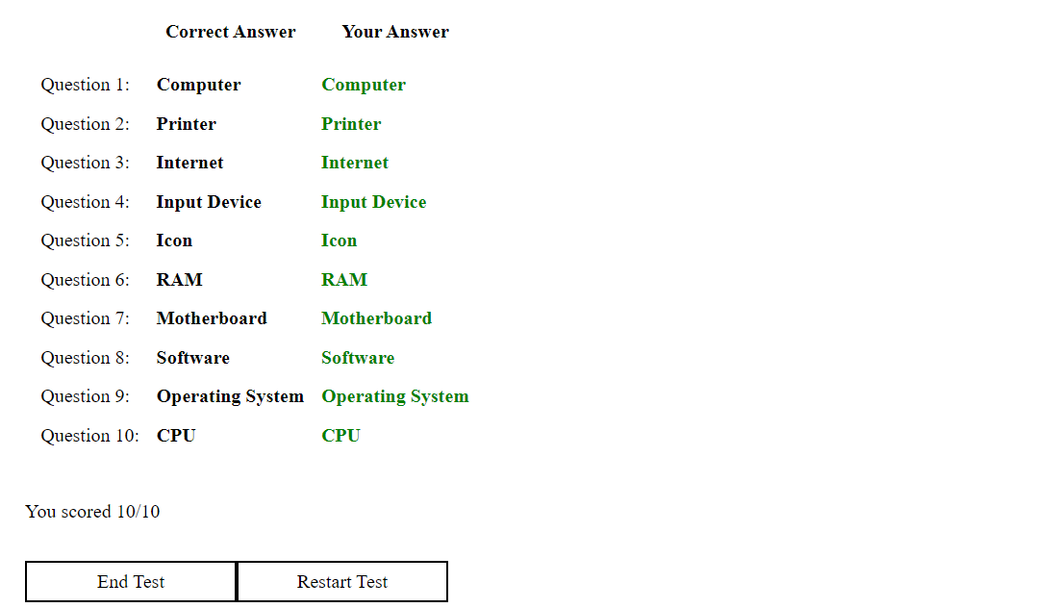

Figure 15: Csc 111 Test Answers

#### 4.3.4.3 All Courses

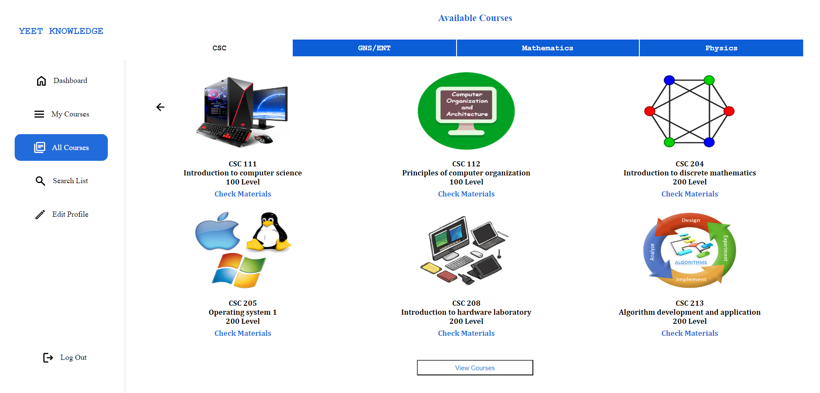

Figure 16: A view of the All courses page

This page displays all courses that can be found on the database. All the courses have been separated according to their fields. The user clicks the view courses button to see the list of all the courses that can be found.

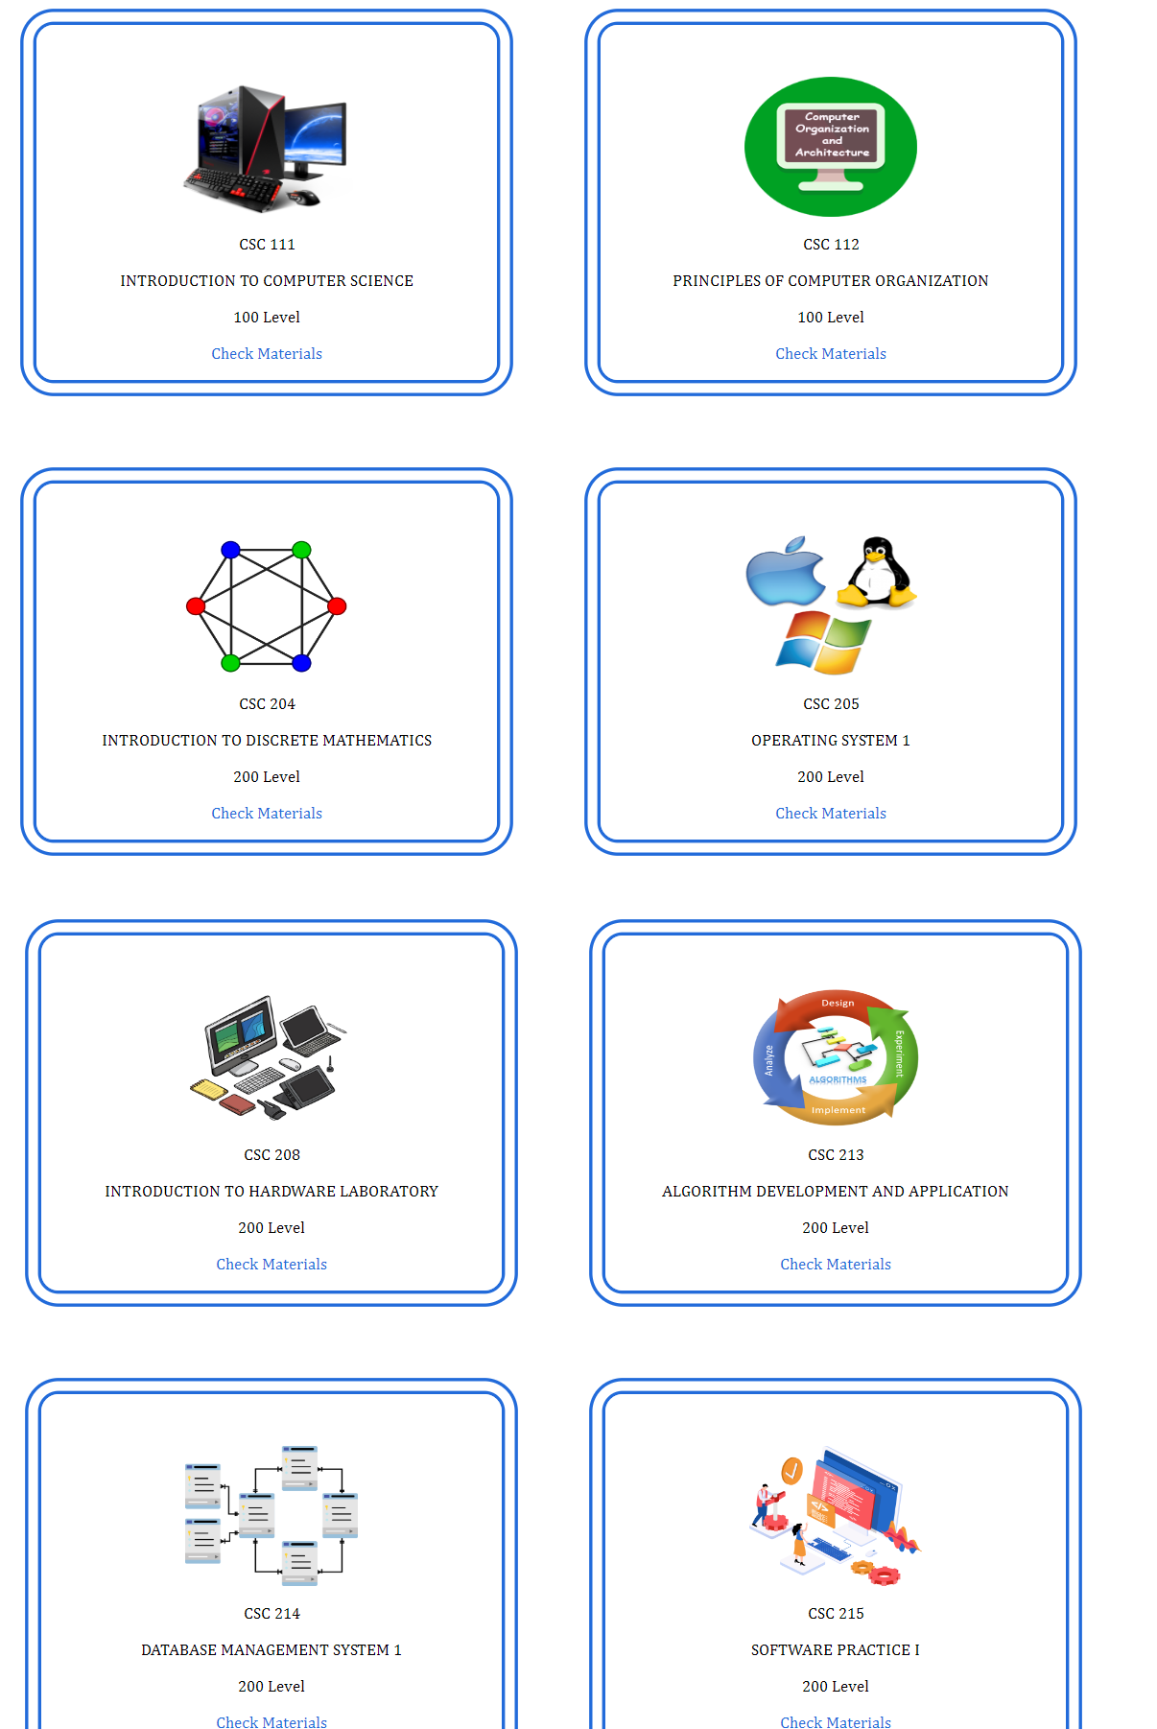

Figure 17: A grid view of the all csc courses

#### 4.3.4.4 Search List

This page searches the database for any content the user is looking for. It searches for any match with the course code or course title and brings out the results.

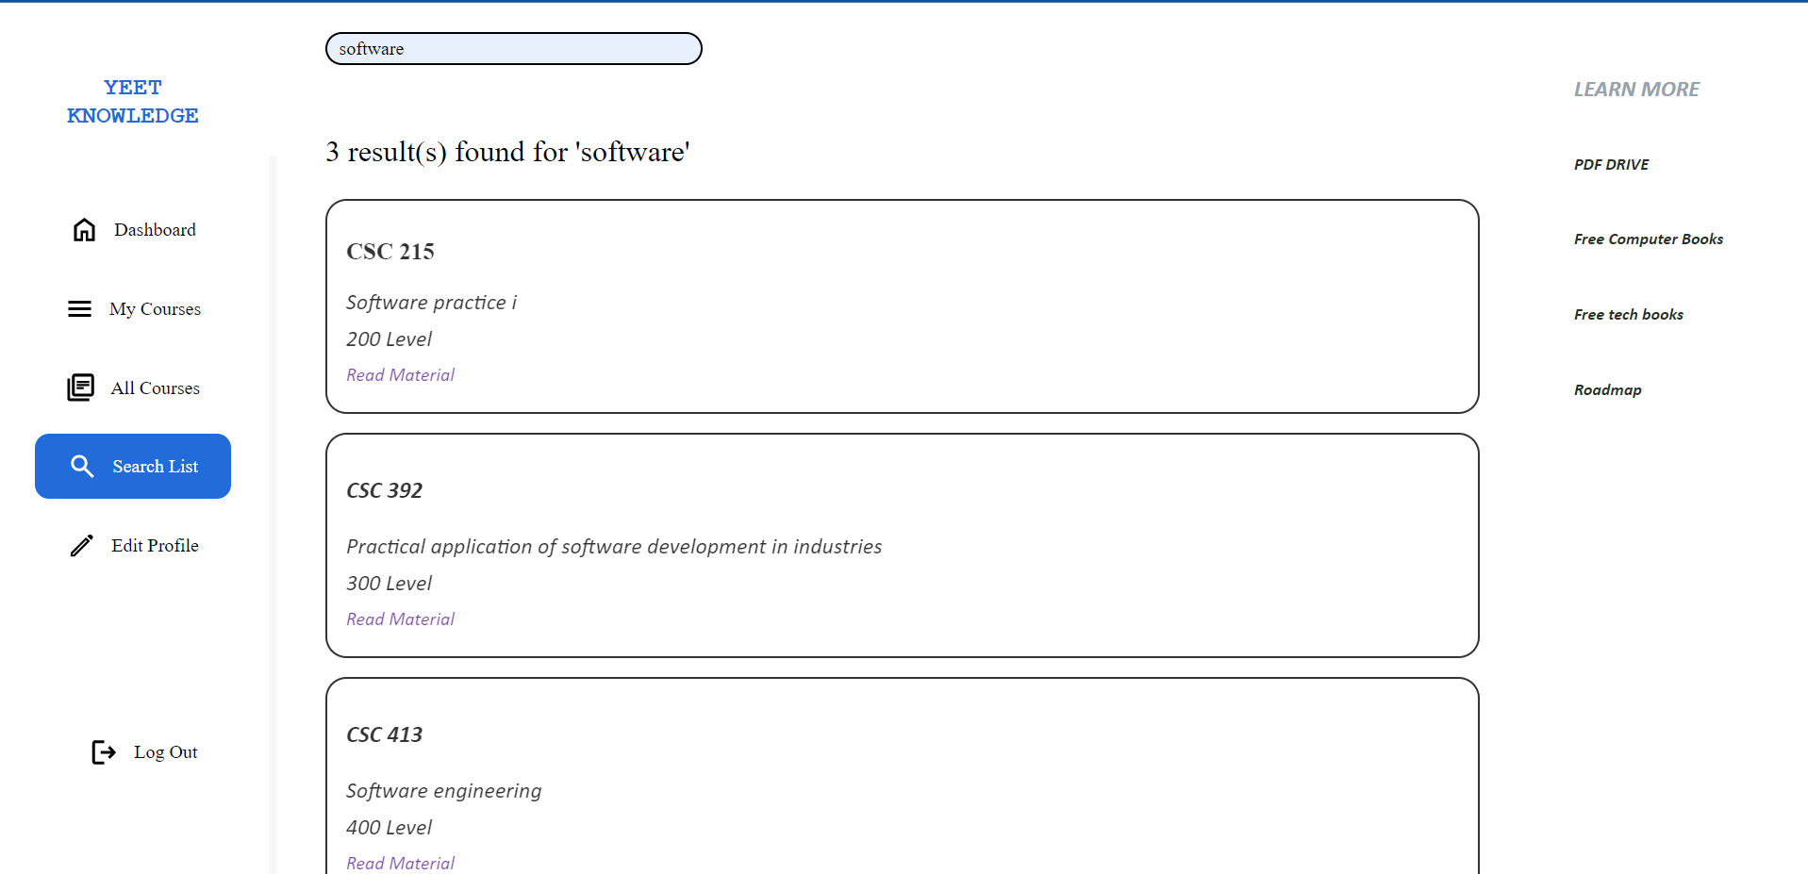

Figure 18: Searching for ‘software’ on the database

#### 4.3.4.5 Edit Profile

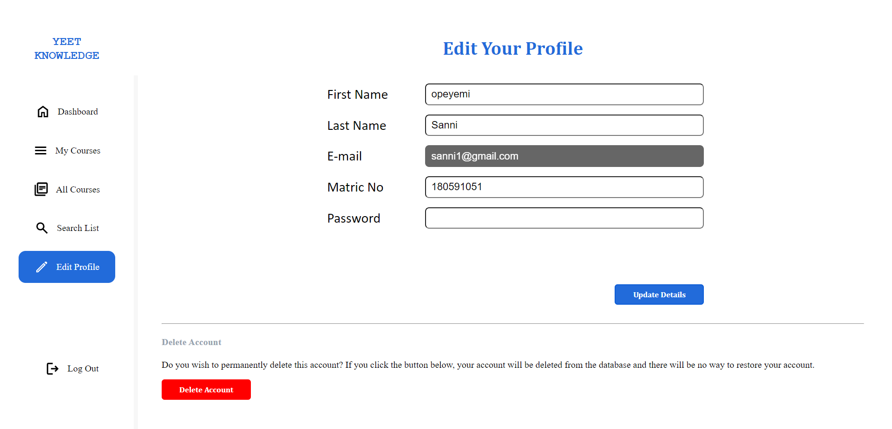

Figure 19: Edit yours details page

In this page, the user can change their account details. The email field cannot be changed. They can also permanently delete their accounts with the delete account button.

#### 4.3.4.5 Log out

The log out button can be found at the bottom left of the screen on the left navigation bar. When it is clicked, it clears the users’ session and logs them out of their account. A screen pops up telling the user the log out was successful and provides the option for the user to log in again or go to the home page. The user is automatically redirected to the home page if there is no response after a few seconds.

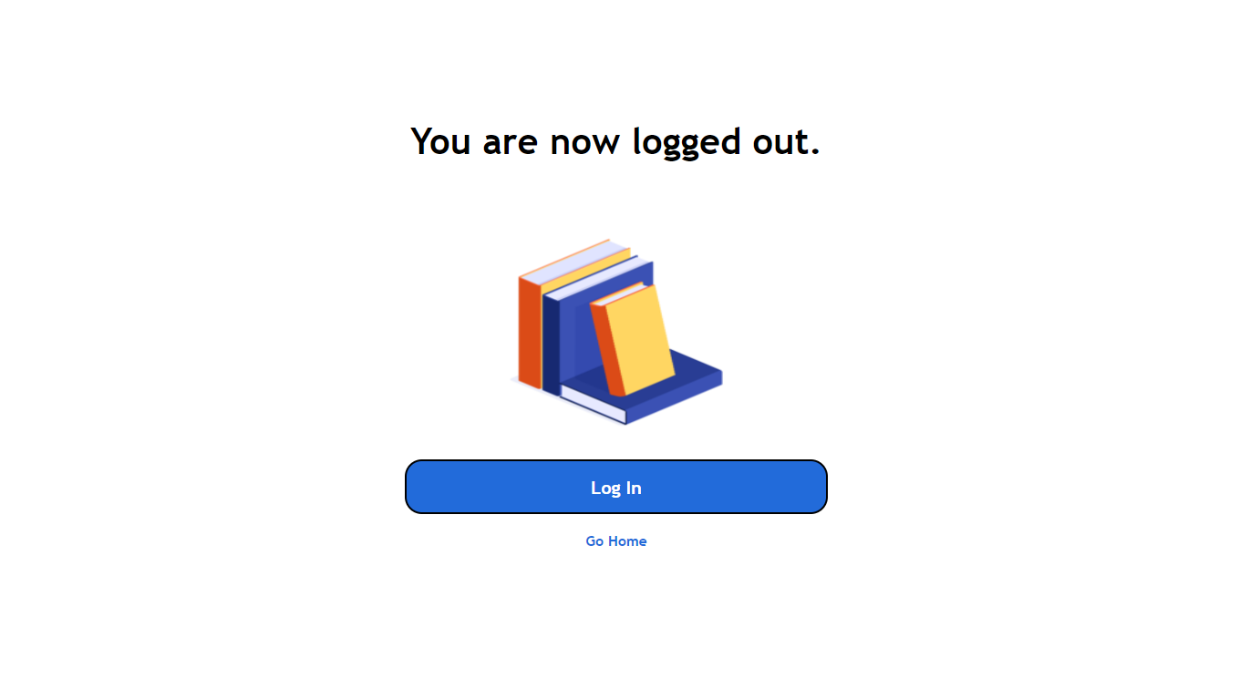

Figure 20: Log out page

### 

### 4.3.5 Learn More page

This page has an FAQ section which contains contents about possible questions that a user might ask and answers to these questions. It also comes with a get in touch section which includes links to various social media platforms of Lagos state university (LASU) where students can get in touch if they have questions about a program or a course.

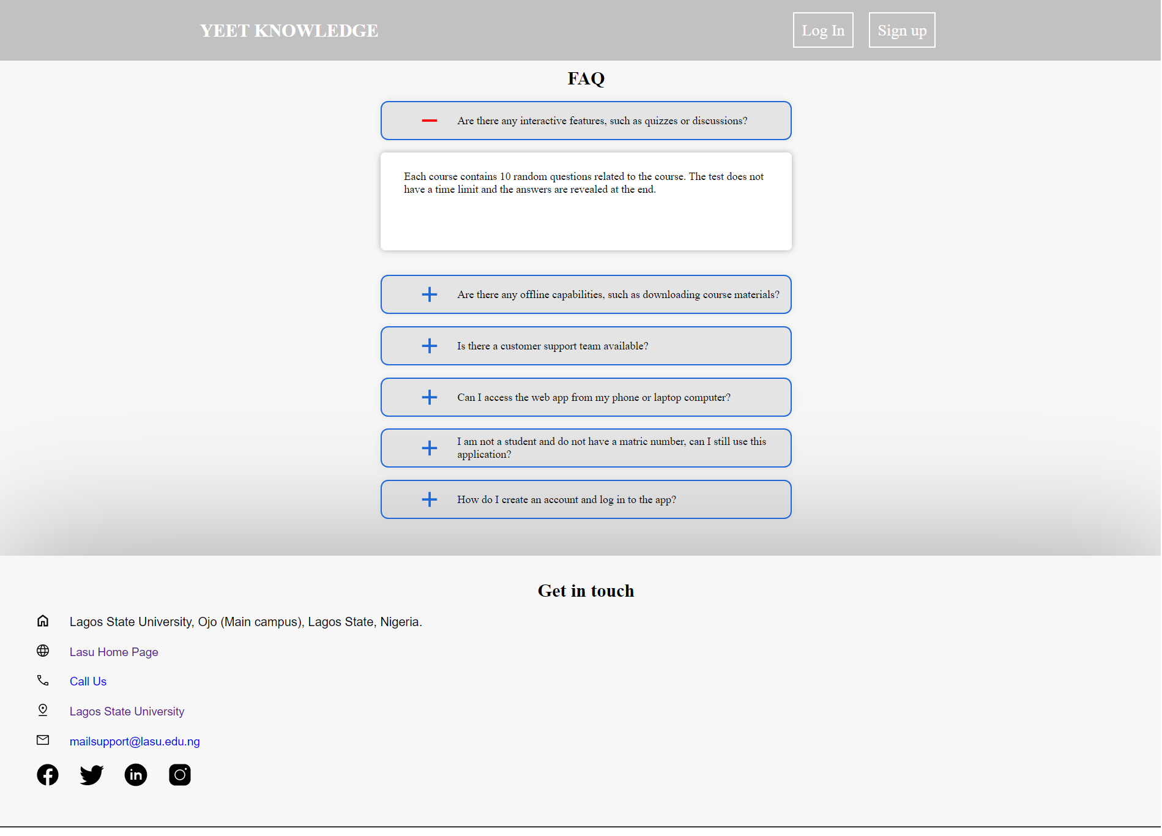

Figure 21: FAQ section

# 

# 

# 

**CHAPTER FIVE**

# **CONCLUSION**

## 5.0 INTRODUCTION

The purpose of this chapter is to discuss and conclude the potential benefits and limitations of web-based e-learning as a method of delivering educational content to students. This discussion is based on a review of existing literature, expert opinions on the topic and explanation of what the web application does.

## 5.1 LITERATURE REVIEW

The literature review on web-based e-learning highlights several key benefits, including convenience and accessibility for students, the ability to reach a larger audience, and the flexibility to deliver content in a variety of formats. Additionally, many experts believe that web-based e-learning can be an effective tool for engaging students and increasing their motivation to learn. E-learning enhances the learners' retention rate to 25% to 60% retention, unlike having one-on-one tutoring, which has a retention rate of 8% to 10%. This is because one can quickly revisit what they learned, and they tend to have more control over the process.

However, there are also limitations to web-based e-learning, including the potential for technological issues and a lack of personal interaction between students and instructors. Additionally, there are concerns about the quality of online educational content, and recently, potential for cheating and academic dishonesty.

## 5.2 IMPLEMENTATION REVIEW

The main objective of the project was to create a web application that serves as an alternative way of attaining education. The project focuses on creating a web application that provides asynchronous learning for computer science students in LASU. The users can read and download materials. In terms of content quality, most of the available materials consist of files recommended or provided by the school's lecturers, as well as past questions from various years. As a result, the quality of these materials can be considered reliable.

The web application contains easy to use navigation features that are designed to guide the user and keep them engaged. The model used for implementation is the ADDIE model which is an instructional design model that includes 5 stages. The web application also features assessment and evaluation, allowing users to take tests for each course. The tests consist of 10 fixed, non-randomized questions, and students may retake them as often as desired. In terms of technical performance, the web application is compatible with all devices that can run a browser which supports php and javascript.

## 5.3 BENEFITS OF THIS PROJECT

The benefit of this e-learning project are:

* It is web based, this means that it can be accessed from any device from any location around the world.
* It uses asynchronous learning, which means that the user can visit the web application at their own convenience.
* It is customised to meet the individual needs of each student, allowing them to focus on the topics they need to improve on.
* It provides assessment through the use of online testing and assessments.
* All materials are organised and arranged making it easier for users to easily get their hands on needed materials which are often difficult to obtain on school premises.

## 5.4 LIMITATIONS OF THE WORK

1. Lack of Social media integration. This refers to the integration of social media platforms, such as Facebook, Twitter, and LinkedIn, into the e-learning website, allowing learners to share content and engage with each other.
2. The system is fully web-based and requires internet connection.
3. It only consists of computer science related topics. It is open to extend to other areas for future work.
4. It uses asynchronous learning, which means it lacks real-time interaction with instructors and other learners. It can feel isolating for some users, it lacks support and resources to help them stay motivated and on track.
5. The assessment only consists of 10 fixed and non random questions. This means that if the test is retaken, the user sees the same 10 questions and in the same order.
6. The system fails to improve collaboration and communication.

## 5.5 EXPERT OPINIONS

To gain additional insights into the potential benefits and limitations of web-based e-learning, expert opinions were sought from educators and researchers in the field. Many experts agreed that web-based e-learning has the potential to be a highly effective method of delivering educational content, but also acknowledged the limitations and challenges that come with this method of delivery.

Some experts believe that e-learning can be as effective as traditional classroom-based learning, if not more so, as students can progress at their own pace and access materials on demand. One of these experts is William Horton, who stated that e-learning can be as effective as traditional classroom-based learning, if not more so, in certain contexts and under certain conditions. Horton emphasises that e-learning is not a one-size-fits-all solution and that the effectiveness of e-learning depends on a number of factors, such as the quality of the instructional design, the suitability of the content for online delivery, and the availability of resources and support for students and instructors.

Other experts believe that e-learning would have a negative effect, they say that it may lead to decreased student engagement, as the lack of personal interaction between students and instructors can result in decreased motivation to learn.

## 5.6 RECOMMENDATIONS FOR FUTURE WORKS

* Include learning analytics features that allow students to track their progress and identify areas where they need to improve.
* Incorporate gamification elements to increase student engagement and motivation. Gamification has proven to be the most successful method of e-learning in making learning more engaging and interactive.
* Provide support for multimedia, including videos, audio, and images.
* Provide collaboration tools such as chat, discussion forums, and virtual classrooms.
* Offer multiple learning paths for students to choose from, depending on their interests and learning styles.

## 5.7 CONCLUSION

In conclusion, web-based e-learning has the potential to be a highly effective method of delivering educational content to students, but it is important to consider both the benefits and limitations of this method of delivery. While the convenience and accessibility of web-based e-learning are attractive, it is important to ensure that the content is of high quality and that the potential for cheating and academic dishonesty is addressed. The experts referenced in this project believe that web-based e-learning will continue to play a major role in the delivery of education, but that it is important to carefully consider the potential benefits and limitations before fully embracing this method of delivery. They also noted that traditional learning should not be abandoned and a blended learning approach should be adopted by schools.

### REFERENCES

1. *Day of 8 Billion | United Nations*. (2022, November 15). the United Nations. Retrieved November 16, 2022 from https://www.un.org/en/dayof8billion
2. Rungta, K. (2022, November 26). *100+ Must Know Online Learning Statistics in 2023*. Guru99. Retrieved from https://www.guru99.com/online-learning-statistics.html
3. Epignosis, L. L. C. (2014). E-learning concepts, trends, applications. California: Epignosis LLC, 5(6), 7.
4. Hendrix, E. (2019, December 19). *How your surroundings affect the way you study*. UCAS. https://www.ucas.com/connect/blogs/how-your-surroundings-affect-way-you-study
5. Statista. (2022, September 20). Internet and social media users in the world 2022. Retrieved from https://www.statista.com/statistics/617136/digital-population-worldwide/
6. Amiti, F. (2020). Synchronous and asynchronous E-learning. European Journal of Open Education and E-Learning Studies, 5(2).
7. ChatGPT (OpenAI). (2023, January 5). Differences between Synchronous and Asynchronous learning. Retrieved from https://openai.com/
8. Fasihuddin, H., Skinner, G., & Athauda, R. (2017). Towards adaptive open learning environments: Evaluating the precision of identifying learning styles by tracking learners’ behaviours. Education and Information Technologies, 22(3), 807-825.
9. Khan, B. H. (Ed.). (2005). Managing e-learning: Design, delivery, implementation, and evaluation. IGI Global.
10. Horton, William (2011). E-learning by design. John Wiley & Sons.
11. Athuraliya, Amanda. 2022. “Top 7 Instructional Design Models to Create Effective Learning Material -.” Creately.
12. Berge, Z. L. (2000). Evaluating Web-based training programs. Web-based training, 515-522.
13. Belanger, F., & Jordan, D. H. (Eds.). (2000). Evaluation and Implementation of Distance Learning: Technologies, Tools and Techniques: Technologies, Tools and Techniques. Igi Global.
14. Keegan, L. (2021, July 20). 79+ Staggering Online Learning Statistics Revealed!???(2022). SkillScouter.com. Retrieved from https://skillscouter.com/online-learning-statistics/
15. Cooke, C. (2022, December 19). *Coursera Review - 7 Pros & Cons You Should Know In 2023*. Upskillwise. Retrieved January 25, 2023, from https://upskillwise.com/reviews/coursera
16. Wood, W. (2022, April 11). *Skillshare Review 2022: Is This the Platform for You?* Mirasee. Retrieved January 25, 2023, from https://mirasee.com/blog/skillshare-review/
17. Robinson, S. (2018, February 20). *New From ATD Research: Is the LMS Dead? | ATD*. Association for Talent Development. Retrieved from https://www.td.org/insights/new-from-atd-research-is-the-lms-dead
18. Gogos, Roberta. n.d. A brief history of elearning (infographic) - eFront https://www.efrontlearning.com/blog/2013/08/a-brief-history-of-elearning-infographic.html.
19. Violante M G and Vezzetti E. Implementing a new approach for the design of an e‐learning platform in engineering education. Computer Applications in Engineering Education, 2014, 22(4): 708-727.
20. Brush, K. (2019). What is a Learning Management System (LMS) and What is it Used For? TechTarget. from https://www.techtarget.com/searchcio/definition/learning-management-system
21. eLearnity (2000), e-learning: The future of learning, eLearnity Ltd, Cirencester
22. Tarhini, A., Hone, K. S., & Liu, X. (2013). Factors affecting students’ acceptance of e-learning environments in developing countries: a structural equation modeling approach.
23. Kim, K. S., & Moore, J. L. (2005). Web-Based Learning: Factors Affecting Students. satisfaction and learning experiences’.
24. Amoako-Gyampah, K. (2007). Perceived usefulness, user involvement and behavioral intention: an empirical study of ERP implementation. Computers in human behavior, 23(3), 1232-1248.
25. Chesney, T. (2006). An acceptance model for useful and fun information systems. Human Technology: An Interdisciplinary Journal on Humans in ICT Environments.
26. Patel, S. R., Margolies, P. J., Covell, N. H., Lipscomb, C., & Dixon, L. B. (2018). Using instructional design, analyze, design, develop, implement, and evaluate, to develop e-learning modules to disseminate supported employment for community behavioral health treatment programs in New York State. Frontiers in public health, 113.
27. Daniels, M. M., Sarte, E., & Cruz, J. D. (2019, February). Students’ perception on e-learning: a basis for the development of e-learning framework in higher education institutions. In IOP Conference Series: Materials Science and Engineering (Vol. 482, No. 1, p. 012008). IOP Publishing.
28. Unwin, T. (2008). Survey of e-Learning in Africa available at www.elearning-africa.com/Publicationssurvey/elearning-africa.pdf.
29. Sindhya, V. (2022). Challenges for teachers during COVID-19. UNIZIK Journal of Educational Research and Policy Studies, 2(1), 1-7.
30. (n.d.). Website Traffic - Check and Analyze Any Website | Similarweb. Retrieved January 5, 2023, from http://similarweb.com
31. (n.d.). Growjo - The Fastest Growing Companies in 2022. Retrieved January 5, 2023, from http://growjo.com
32. Perveen, A. (2016). Synchronous and asynchronous e-language learning: A case study of virtual university of Pakistan. Open Praxis, 8(1), 21-39.
33. Emmanouilidou, K., Derri, V., Antoniou, P., & Kyrgiridis, P. (2012). COMPARISON BETWEEN SYNCHRONOUS AND ASYNCHRONOUS INSTRUCTIONAL DELIVERY METHOD OF TRAINING PROGRAMME ON IN-SERVICE PHYSICAL EDUCATORS’ KNOWLEDGE. Turkish Online Journal of Distance Education, 13(4), 193-208.
34. Epic Group plc (1999), Taking Training Online: Exploiting the potential for web-based training in the UK, Technologies for Training Ltd and Epic Group plc
35. 9 Advantages and Disadvantages of JSON to Pay Heed to. (2022, January 5). Tech Quintal. Retrieved November 29, 2022, from https://www.techquintal.com/advantages-and-disadvantages-of-json/